**The International Students Olympiad in Hot Bulk Forging Technologies**

*CODE 50*

# *1. Task – Gear.*

The company taken an order to produce 20,000 ‘gear’ parts. It is necessary to develop the technological process for manufacturing of forgings for further machining. The following equipment is available for order fulfillment:

• 3 mechanical presses (16 MN)

• 2 Power-drop steam hammers (2 t, 50 kJ)

***Task notes***

Create a report containing the process description and results of performing task including calculations and justification of the proposed technology, applications and drawings in text file. Simulation should be done in QForm software for estimation and verification of the developed technology.

It is recommended to use deformed material technology model (*.qdat file is attached to the task) produced by Institute for Metal Forming (TU Bergakademie Freiberg, Germany). Equipment models are introduced in Attachment 1.

The designed technology will be judged by the following criteria:

• design of the hot forging part based on final detail drawing;

• justification of the designed bulk forging technology (Choice of equipment, the number of forging steps);

• efficiency and optimality of the proposed technology should be based on the Qform simulation results. The optimally designed technology should be without any defects, complete filling of the die impression, consist of a minimum number of technological chain steps with high forging energy efficiency and high material consumption efficiency with optimal grain flow.

You have 6 hours to design the technology, to simulate it and to create a report using a text editor.

At the end of the work you have to create an archive (use special number provided by committee) which include a report and a QForm simulation file (without data folder) of a single final process version. The report title and QForm files have to contain your special number too. Do not specify your name and surname.

*f**ig. 1‑ Detail drawing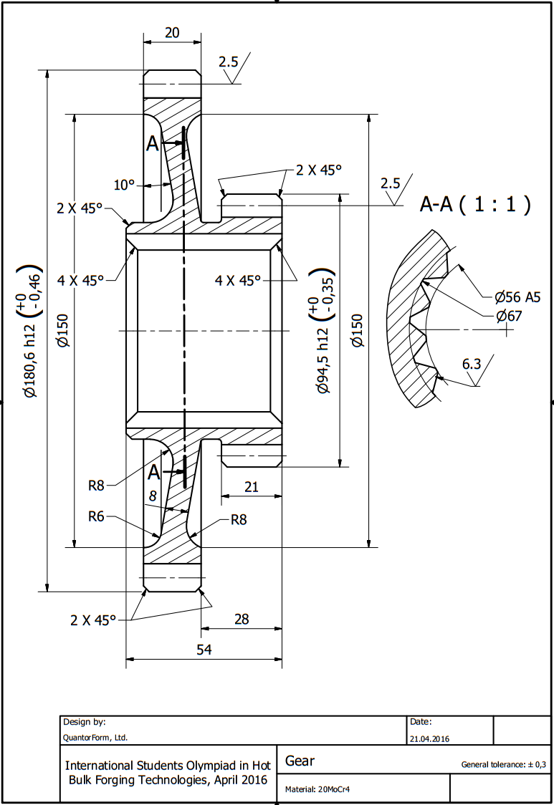*

# *2. Development of forged part drawing.*

The forged part drawing is developing by the detail drawing, (fig.1), following the BDS EN 10243-1:2003/AC:2005 “Steel die forgings - Tolerances on dimensions - Part 1: Drop and vertical press forgings ”.

The standard refers to steel forgings with weight up to 400 kg and determined a maximum value of the additives for machining, tolerances on dimensions and etc. The development of specific technology and drawing of forging allows reduction of these values in order to save material, increasing accuracy and increase the durability of tooling. Depending on the purpose and operating conditions of the part, forgings are divided into categories in terms of: ***accuracy of manufacturing (tolerance grade ), material (group of steel), degree of complexity and configuration on the parting line of dies.***

**2.1. The tolerance grade** ischosen from 2 possible grades: ***I*** and ***II***.

Standard provides two classes forgings - Class I-st - forgings with increased accuracy and  
Class II-nd - forgings with normal accuracy.

For this forgings the tolerance grade is II-nd Class.

**2.2 The group of steel** should be determined from the following table *(table 1)*:

*Table 1. Determination of steel group*

|  |  |  |
| --- | --- | --- |
| Group of steel | Carbon mass fraction, % | Total mass fraction of alloying elements, % |
| **M1** | Up to and including 0.45 | Up to 2.0 |
| **M2** | More than 0.45 | More than 2.0 |

The group of steel assumed for steel 20CrMo4 (*C*≤ 0.17-0.23%, *Si*≤ 0.4% , *Mn* ≤ 0.6-0.9%, *Cr*≤ 0.9-1.2%, Mo≤  0.15-0.25%, Al= 0.05% and Cu=0.3% ) is ***M2*** with carbon mass fraction up to 0.45% and the total mass fraction of alloying elements more than 2% .

**2.3 The degree of complexity** (***C1, C2, C3*** and ***C4***) is determined according to the formula:

*C = MF.P./ MS.F.*;

where M*F.P.*– is the forged part mass, M*S.F.*– is the mass of the simplest geometric figure, which the forged part may be inscribed in. In this case, a figure the forged part inscribed in is a cylinder, but the mass of forged part is not determined. Therefore, we determine the estimated degree of forged parts complexity *CEST* according to the formula *[2].*

*CEST =MF.P.C./MF.C*;

where M*F.P.C*. – is the calculated mass of forged part (estimated); M*F.C.* – is the calculated mass of the figure (cylinder) (estimated).

*MF.P.C.= MD.K****C***;

where *MD*– is the mass of detail, *KC*– is the design coefficient that is assumed depending on the configuration of forged part.

The mass of detail may be determined by using of SolidWorks software package while choosing the steel 20CrMo4 (defining it’s density fig.2).

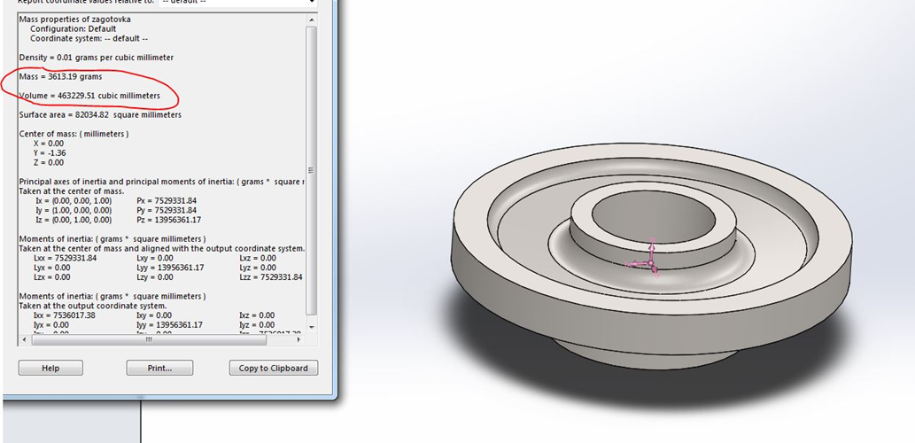

*fig 2. Determination of MD value*

VD= 463230 mm3 ; MD= 3.613 kg

The coefficient KC = 1,5÷1,8 for round forged parts such as gear, hub, and flange. Then, KC = 1,5.

MF.P.C.= MD.KC = 1,5.3,613 =5,4195 kg

The MF.C. is determined on a basis of increasing by 1.05 times the overall linear dimensions of the simplest figure, cylinder, which the detail may be inscribed.

MF.C = [ρ.π. (0,1806.1,05)2 .0,054.1,05]/4=12,571 kg

*CEST =MF.P.C./MF.C* =5,4195/12,571=0,43

→ which is corresponding to the degree of complexity C2 [0,32÷0,63]. The estimated degree of complexity should be refined after calculating envelopes of the metal.

A drawing of forging is developed in the following order :  
- Configuration on the parting line of dies;  
- Selection of machining datum surface and determination of the additives for machining;  
- Determination of the drafts for die forging (external and internal);   
- Determination of the fillet radii for die forging (external and internal);   
- Determination of the position, shape and dimensions of the barrier metal layer for the openings in the forged part;  
- Determination of dimensional tolerances for the forged part;

**2.4. Configuration on the parting line of dies**

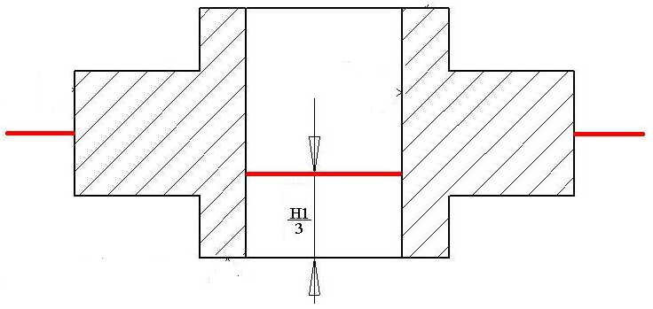

External - from the half of the biggest diameter

Internal - from 1/3 of the height

**2.5. Selection of machining datum surface and determination of the additives for machining.**

The selection of machining datum surface is made from the drawing of the part (fig.3).

According to the standard the additives are determined depending on the weight of the forging, tolerance grade (II class), the group of steel (M2), the degree of complexity (C2) of forging, size and roughness of the plane, which concerns the additive.

For this gear we use table 2 to determinate the additives for machining.

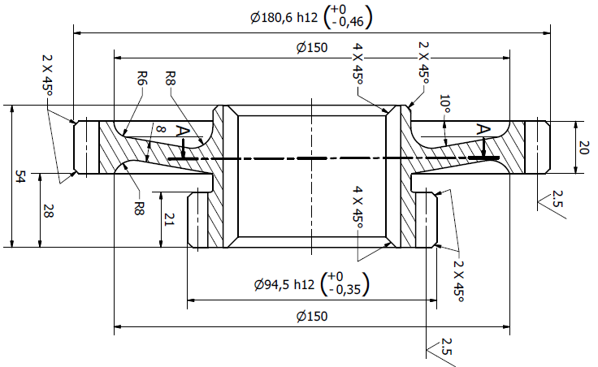

*fig.3 Drawing of the part*

*Table 2. Additives for machining*

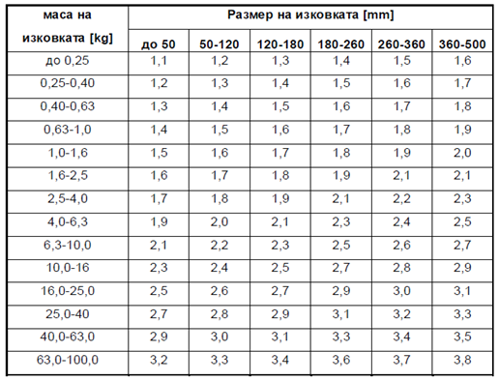

The largest dimension of the forging will be more then 180mm so I choose the additives for machining to be 2,3mm. The smallest dimension of the forging is more then 50mm so the additives for machining from 50 to 120mm is 2 mm, and from 120 to 180 is 2.1mm.

**2.6 Determination of the drafts for die forging (external and internal)**

From the standard when we use mechanical presses the drafts for die forging will be:

* external - 5º;
* internal - 7º.

**2.7 Determination of the fillet radii for die forging (external and internal);**

From the standard we use table 3 to determinate the external fillet (R). The internal fillet (r) will be r=2÷3R

The external fillet is 2,5 mm and the internal is 5 mm.

Table 3 . External fillet

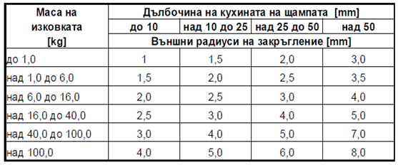

**2.8 Determination of the position, shape and dimensions of the barrier metal layer for the openings in the forged part**

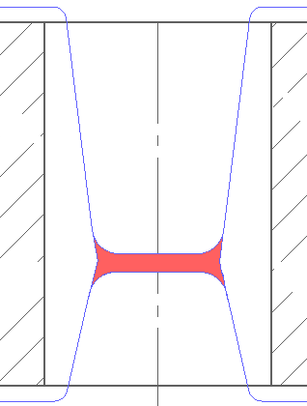

The shape and dimensions of the barrier metal layer is defined from the ratio of the height (hbl) and diameter (dbl) of the barrier metal layer in final step.

hbl/dbl = 0,76 – if the ratio is between 0,4 < h/d < 0,85 the width (S) of the barrier metal layer will be :

 =6.4 mm

**2.9 Determination of flash land and flash gutter configuration and flash mass**.

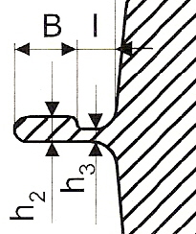

Dimensions of gutter depend on flash thickness h3 on the gutter ridge that may be calculated using the following expression:

h3=0.015*D =2.7 mm

For the dimension h3, choose the nearest higher tabular value of the calculated in the above formulas. The main dimensions of technological gutter ridge are given in table 4.

Table 4. Dimensions for the gutter ridge

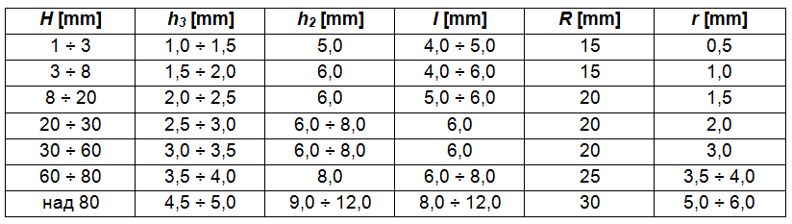

The dimension H is determined by the height of the forging and actually represents the depth of the cavity of the stamp (H1 / 3).

The value of B depends from the mass of the forging and is defined as follows:

B=20 mm when the mass of the forging is above 2 kg.

The other values are:

h2=7 mm

R=20 mm

r=2 mm

I= 6 mm

**2.10 Development of forged part drawing for die making**

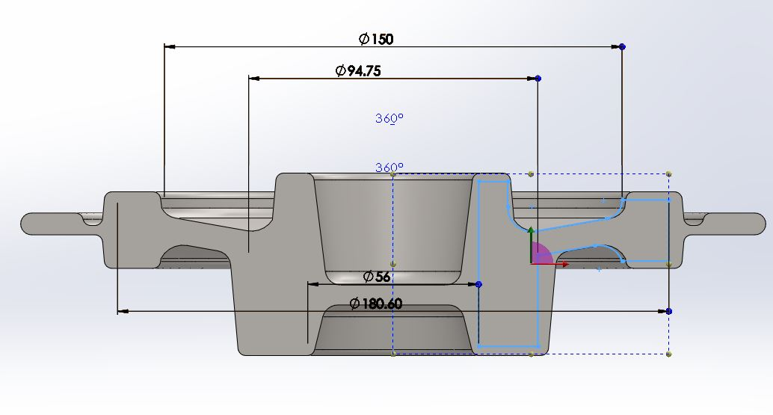

The forged part drawing for making of finishing impression has been developed on a basis of inspection (acceptance) forged part drawing. The forged part drawing has been performed on the same scale with inspection drawing, and dimensions have placed with taking into account a shrinkage, i.e. increased by 1.5 % compared to design dimensions. The «hot forged part drawing» has been obtained.

**2.11 Determination of initial workpiece dimensions.**

The volume Vw of the workpiece is defined as the sum of the volume of the forging Vf (including the volumes of the barrier metal layers ), the volume of the technological gutter Vg and volume from oxides Vo resulting from the combustion of the surface layer of the metal on heating.

Vw = Vf + Vg + Vo

Losses of metal from oxidation during heating of the workpiece is recorded by the coefficient δ [%] and depends from the mode of heating as follows:

1. if heated in a flame furnace with fuel oil - δ = (1,5 ÷ 2,0)%;

2. for induction heating - δ = (0,8 ÷ 1,0)%.

Vo=( Vf + Vg ). δ/100

The volume of the workpiece is obtained directly in the Mass Properties of the 3D product (without taking the losses in value). The resulting value is increased (with the command Scale) to the value of δ.

To prevent buckling of forging and ease of cutting it’s ratio of size m = Lw / Dw is selected in the range of 1.5 to 2.8.

- m =1.8

=82 mm

The length of the forging is calculated by the formula:

=151mm

The volume of the workpiece is Vw= 798110 mm3

**2.12 Determining the type and number of operation for hot forging**

I choose to use two operation.

Tools for operation 1.

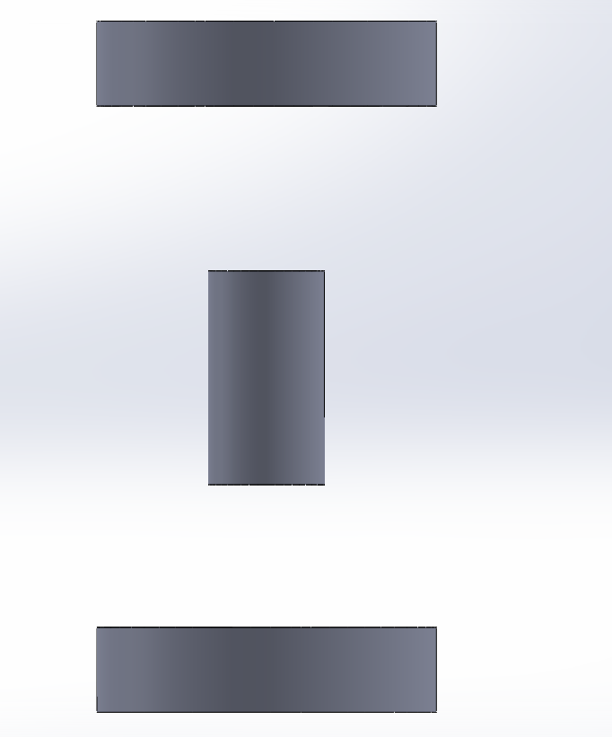

Tools for operation 2.

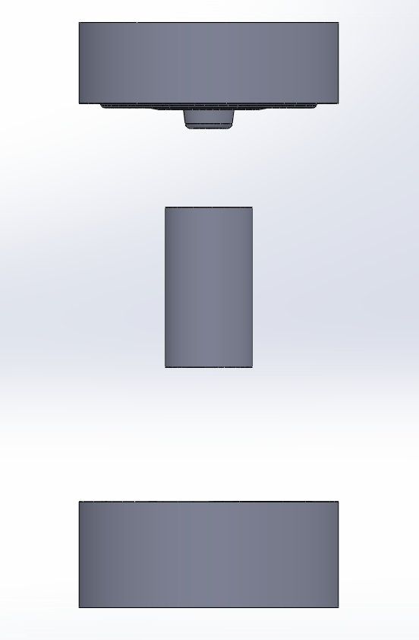

**2.13 Simulation in QForm 8.**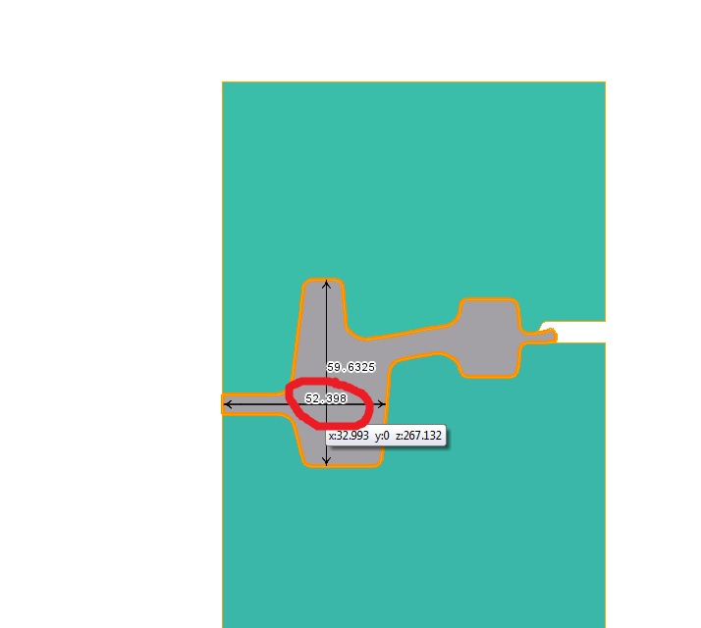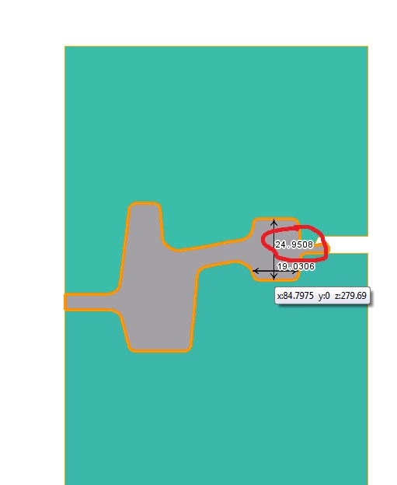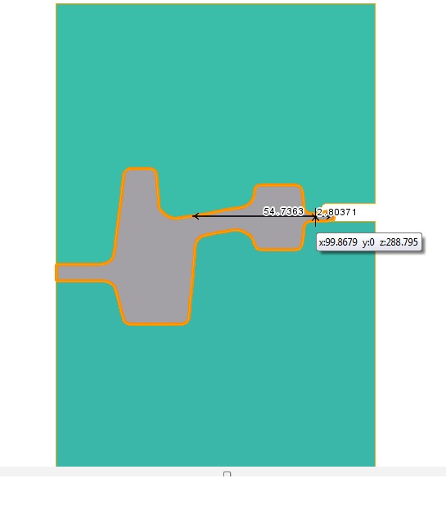

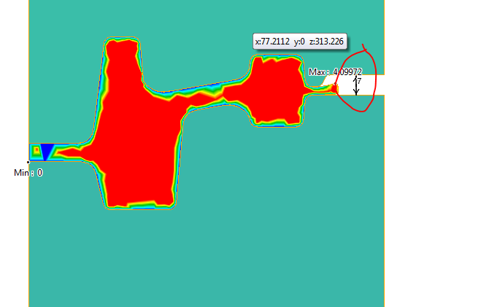

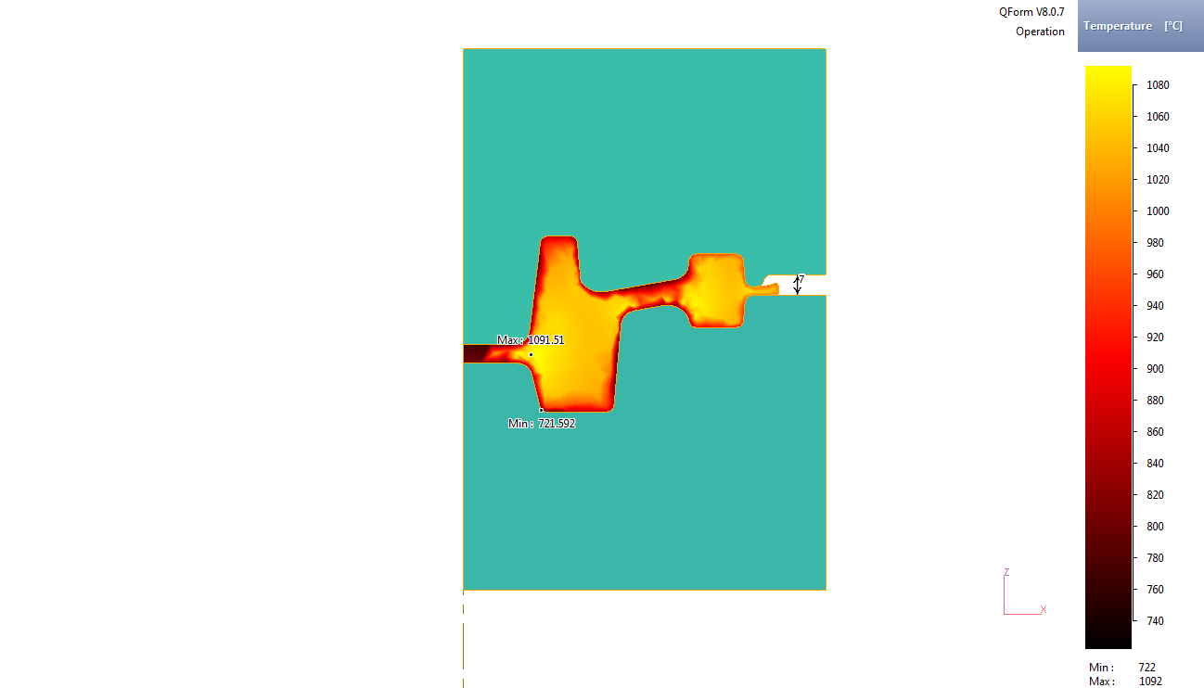

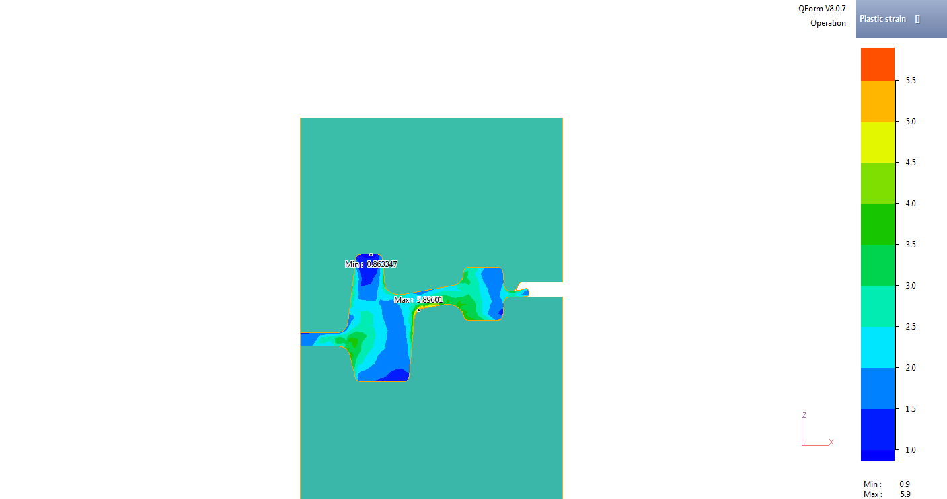

Load graph:

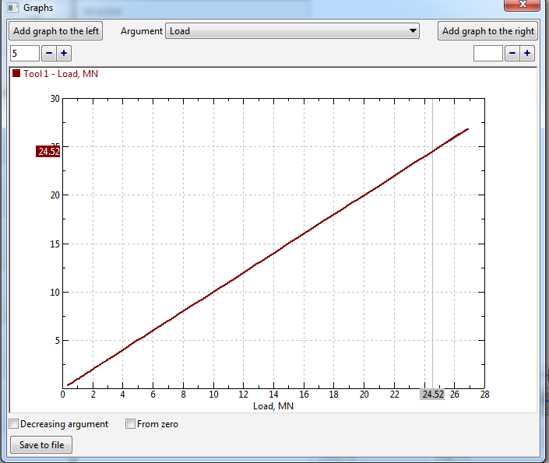

4.5. Work graph

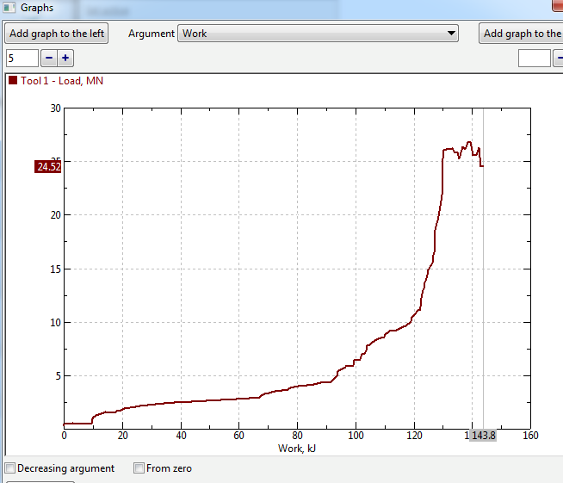

Conclusions:

There has been developed a technological process for manufacturing of forgings for ‘gear’ parts, in sequence of two operations:

- 1-st preliminary - axial upsetting (flat-die forging); and

- 2-nd final - impression-die forging;

using a mechanical press (16 MN).

The height of the flash in the final stage of the filling of die cavities is 2.7 mm.