The International Students Olympiad in Hot Bulk Forging Technologies

CODE 273

Task
The task of this olympiad was to develop the forging process of a gear, based on a drawing of the final (machined) part as shown in Figure 1.1.
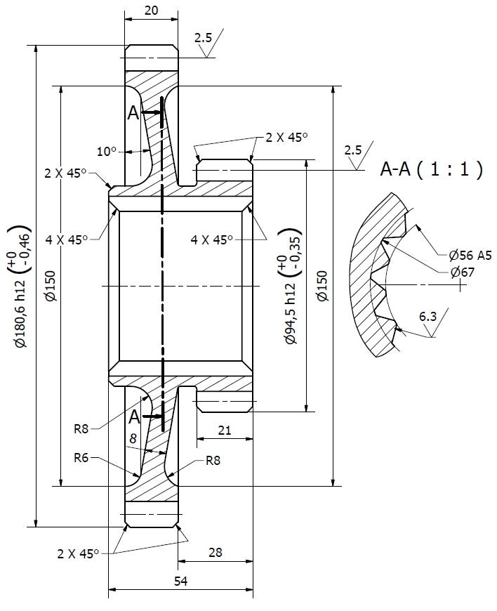
Figure 1.1: Drawing of the machined gear

Design of the forged part
The tolerances of the forged part could be determined by transforming the measures given in the drawing with the aid of the standard DIN 10243-1. The first step was to calculate the weight of the final part in order to estimate the weight of the forged part. With the quotient between the weight of the forged part and the weight of the enveloping body of the final part, the refinement factor S could be set to S3.
Because of the carbon content of 0,2 % for the workpiece material 20MoCr4, group M1 was chosen for the steel grade (see DIN 10243-1).
Furthermore, the forging grades „E“ and „F“ were allocated to the measures, depending on the particular surface roughness.
In general, it is important to say that through the forging process, it is not possible to produce a hole. Because of this fact, there is a bottom remaining in the middle of the forging. Draft angles of about 7° to 10° enable a correct ejection of the part after the forging process. Moreover, appropriate radiuses at the edges of the forging reduce significantly the stress of the tool and extend the tool life. The result of the designing process is shown in Figure 2.1 and Figure 2.2.
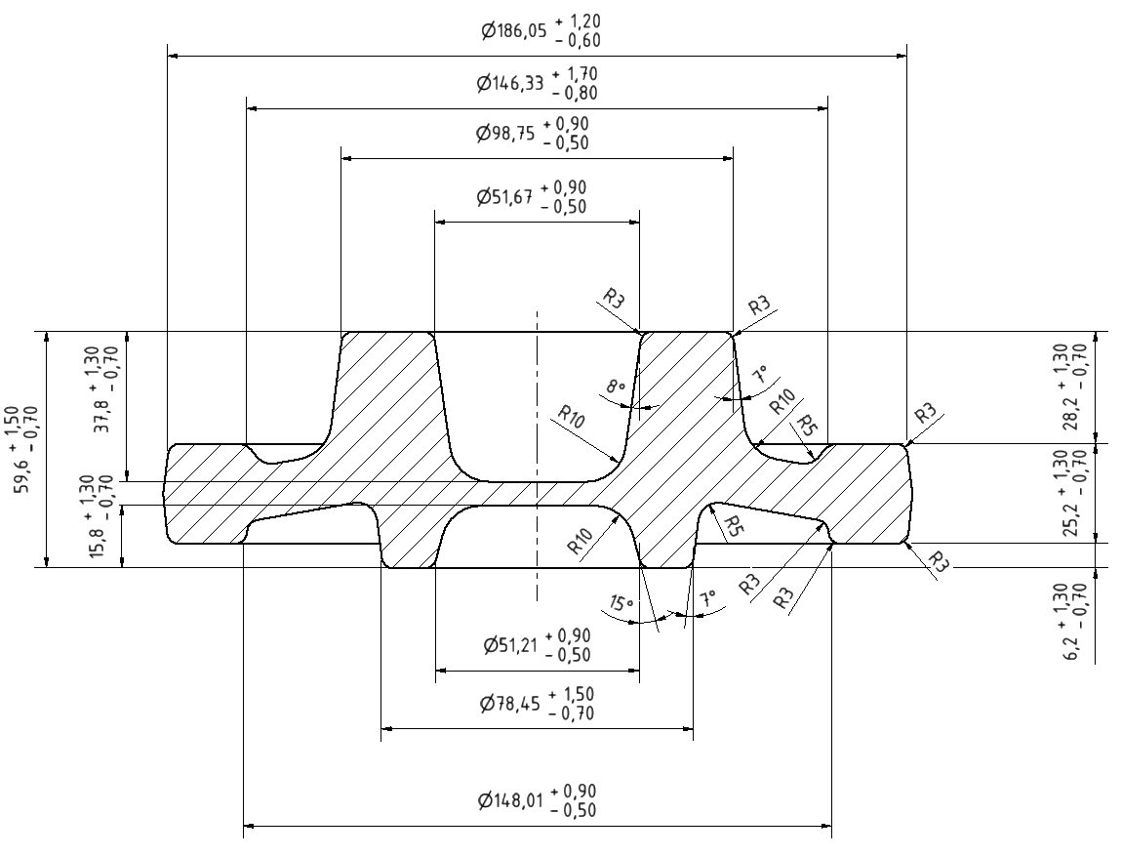
Figure 2.1: Drawing of the forged part
By using DIN 10243-1 to determine the tolerances, each type of displacement (e.g. through thermal effects) is already included.
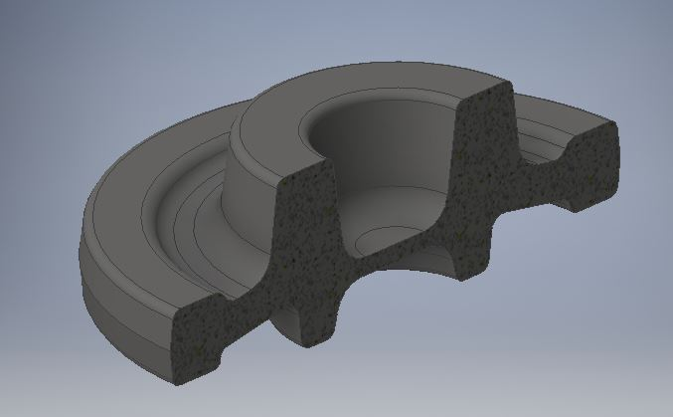
Figure 2.2: 3D model of the forged part

Design of the billet
The dimensions of the billet could be defined through the volume of the forged part. First of all, the diameter of the billet was set to 80 mm and the height accordingly to 155 mm to prevent buckling. Normally, the billets for hot forging are set to length by shearing. Because of the big burr formation when shearing large diameters, the diameter of the billet was chosen to 80 mm.
In the following table, there is some information regarding the raw part:
Material | 20MoCr4
Density | 7,85 g/cm³
Volume forged part | 735455,49 mm³
Volume raw part | 779114,98 mm³
l/d quotient of the billet | 1,94

Regarding the dimensions of the billet, it is important to say that the length of the billet had to be enlarged a bit because a first simulation said that the die was not filled completely. Through an appropriate design of the flash gap, the engraving could be filled completely due to a high internal pressure.

Production sequence
Because of the chosen billet dimensions, the relatively small thickness and the big outside diameter of the forging, it was advantageous to forge the part in three steps. When using more steps, cooling effects should always be kept in mind. The forming forces will rise when the part cools down. Because of this fact, a fast transfer between the steps is recommended.
In the first step (see Figure 4.1) there is an upset forging and a centering operation at the bottom side of the billet. The centering has a circular design to approximate the engraving of the lower die of the second operation.
The second step (see Figure 4.2) is a preforming operation without a flash gap. The advantages of such an operation are on the one hand the smaller tool stress and on the other hand the reduced risk of wrinkles.
The third operation (see Figure 4.3) is the final forging step with a flash gap, so that an adequate internal pressure can be built up inside the tool.
The simulation parameters are shown in the following table:
Material | 20MoCr4
Forging temperature | 1200 °C
Lubricant | Graphite and water
Press drive tool 1 | Hammer (50 kJ impact energy),  motion into negative z-Axis
Press drive 2 | Stationary
Material of the tool | H13 HRC50
Temperature of the tool | 200 °C
Environment | Air, 20°C
Strokes | At OP1: one stroke  At OP2 and OP3: 4 strokes each
Cooling of the part | Transfer: 2 sec, tool: 1 sec

 | 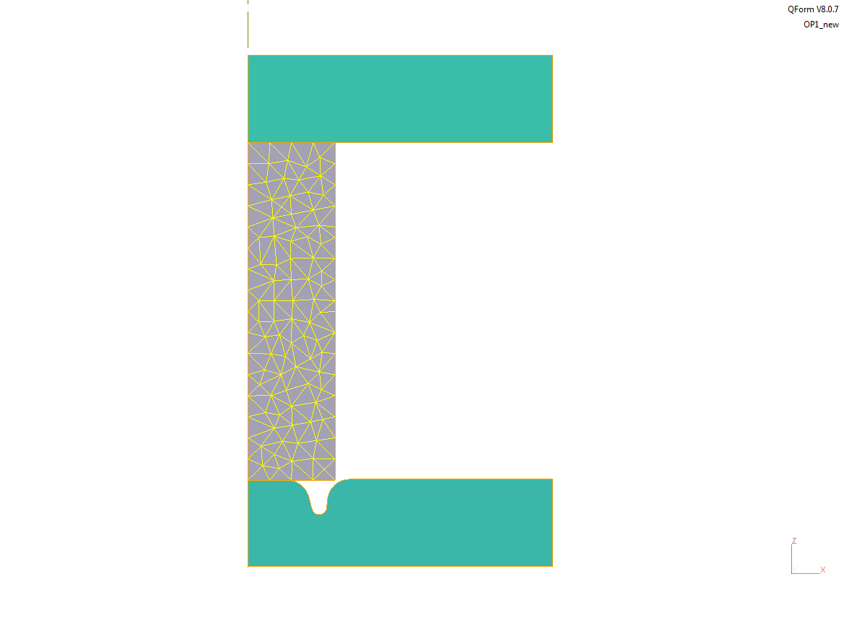 |  | Figure 4.1: Operation 1 (before forming)
 | 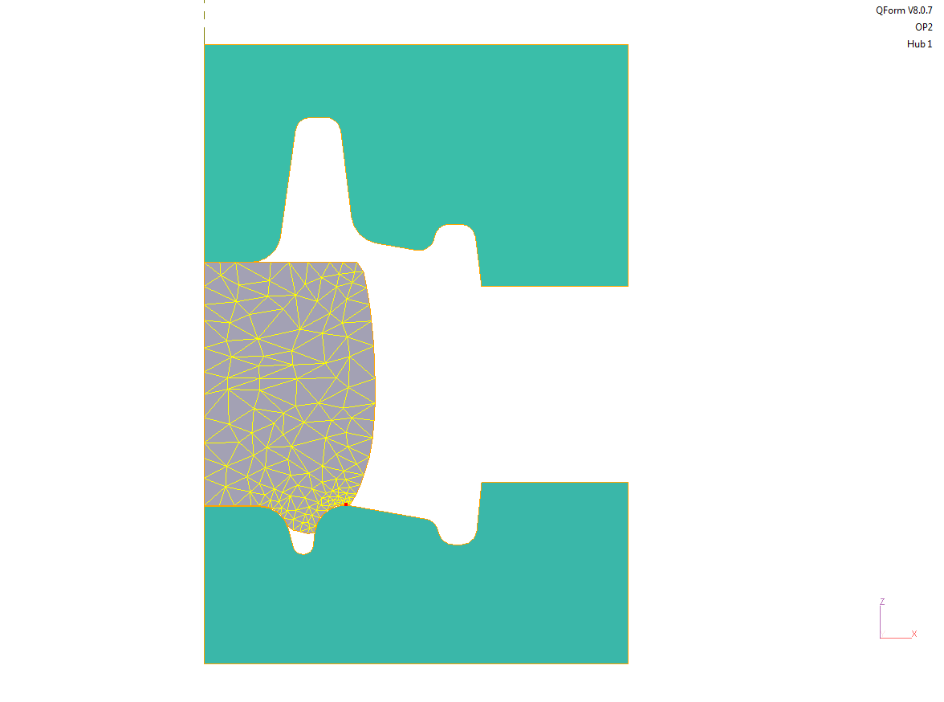 |  | Figure 4.2: Operation 2 (before forming)
 | 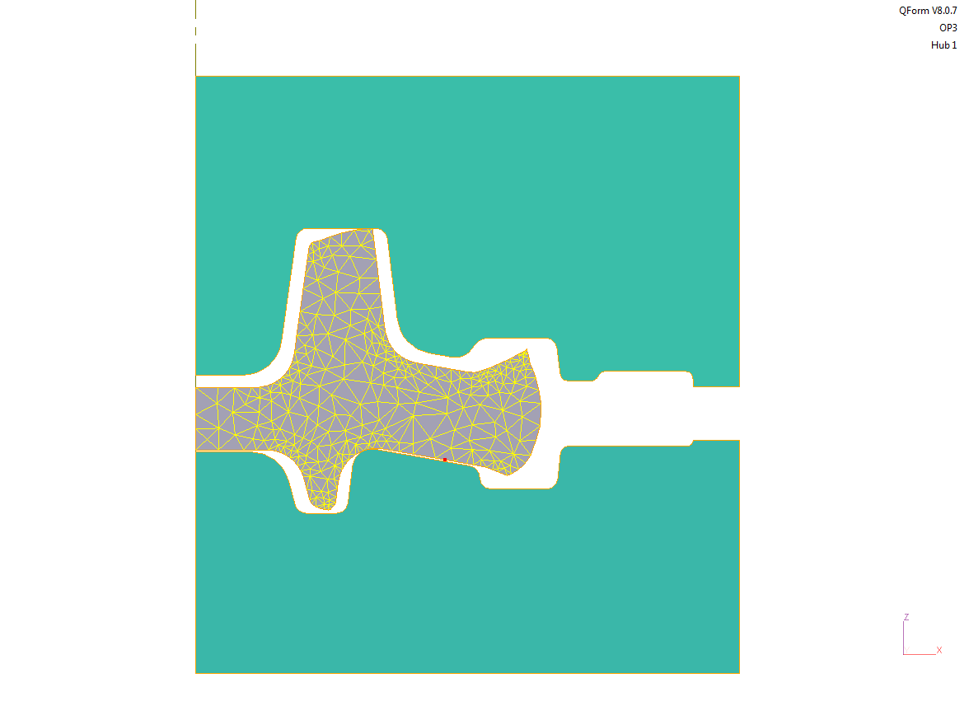 |  | Figure 4.3: Operation 3 (before forming)

Simulation results
In the following passage, the results of the simulation are presented. In this case, the temperature distribution and the plastic strain are the most significant parameters. With the help of the temperature distribution, it is possible to analyze the cooling process of the workpiece. During the forging in Figure 5.1 shows a high temperature in a large part of its profile, the temperature distribution changes in the following steps.
In general, it can be realized that the cooling at the bottom side of the part is the biggest. A reason for this effect is the long contact time of the workpiece with the lower die and the following big heat transmission. In step two (see Figure 5.2) the part has mostly cooled down to about 1000 degree Celsius in the area near to the bottom surface. The cooling of the forging leads to a raise of the forming force because of the fact, that the yield stress k_{f} depends on the temperature.
At the end of operation three (see Figure 5.3) the forging has further cooled down and the part is completely shaped.
 | 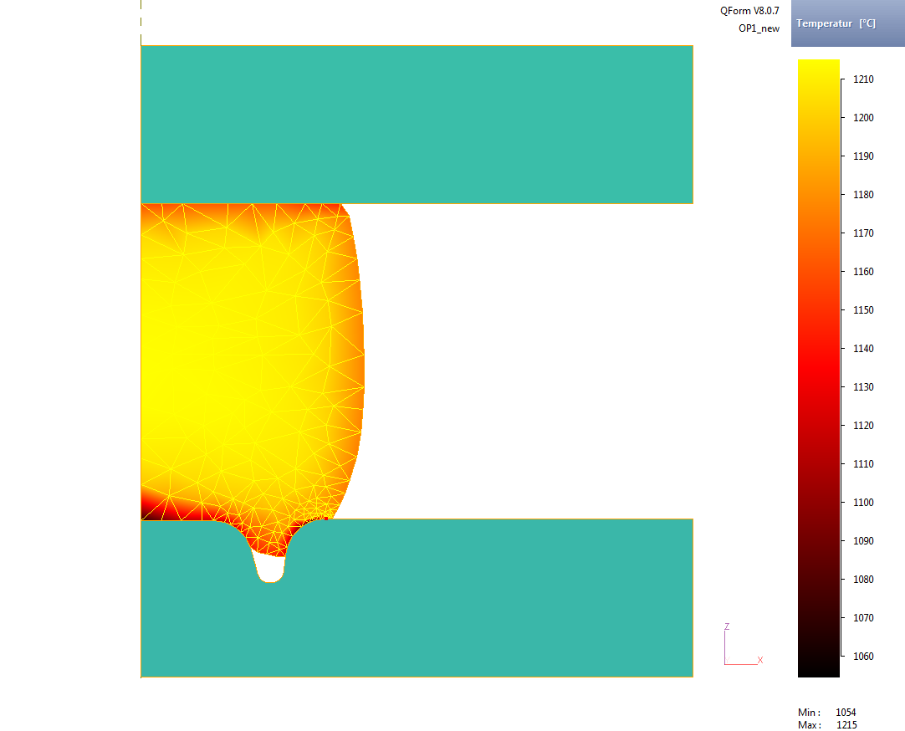 |  | Figure 5.1: Temperature distribution of operation 1
 | 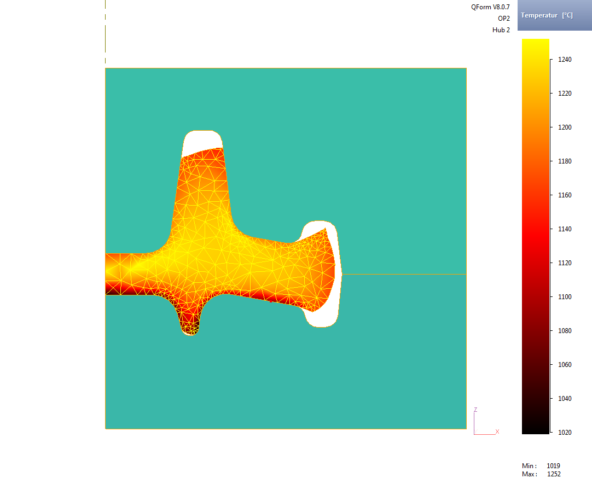 |  | Figure 5.2: Temperature distribution of operation 2
 | 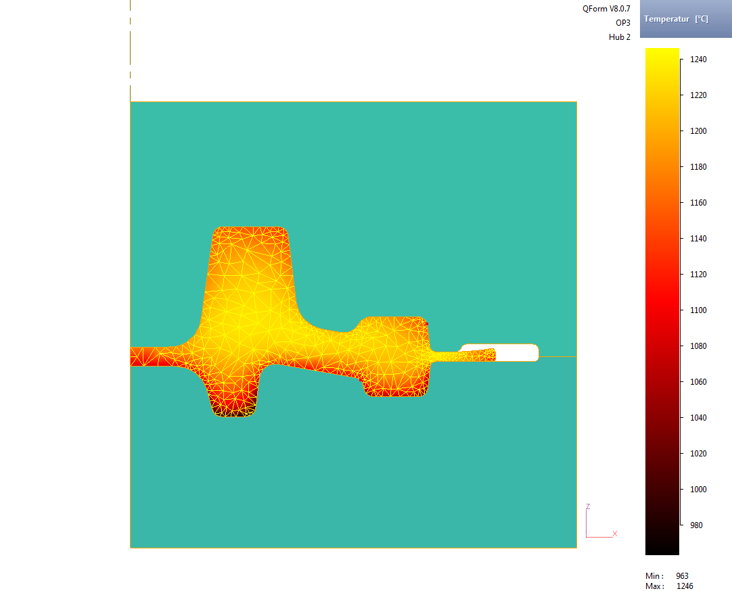 |  | Figure 5.3: Temperature distribution of operation 3
The second important criterion is - as already said - the plastic strain which allows a specific failure prediction. The natural strain is defined as the logarithmic plastic deformation. Following this definition, areas which are colored red in the figures below show a high plastic strain. In the first step (see Figure 5.4), the area around the centering shows the largest plastic deformation. Due to the given geometry of the next step, it was necessary to design the engraving with small radiuses. Because of these small radiuses, the plastic strain in this area is relatively high. An analysis of the steps has shown that there is built a small wrinkle at the end of the first step (shown as a small red dot in Figure 5.4). The wrinkle formation is a consequence of those tight radiuses and the associated high friction between the workpiece and the lower die. Furthermore, it is important to say that the wrinkle never disappears during the complete forming process.
At the end of the second operation (see Figure 5.5) there is a high plastic strain in the area of the upper die. During in the first step, there is only formed the centering, the second operation gives the complete preform to the part. Maybe, a further preforming operation of the upper area of the part already in the first step would have been advantageous in reference to the plastic strain. In the area of the future gear teeth at the outside diameter, there is a difficult situation regarding the material flow which is a consequence of a suboptimal die. The material flows free without any restriction (e.g. friction at the tool walls) into the engraving and deforms at random. This random deformation results in the following operation in a wrinkle (see ret dot in Figure 5.6). Unfortunately, the wrinkle lies in the area of the future teeth of the gear.
 | 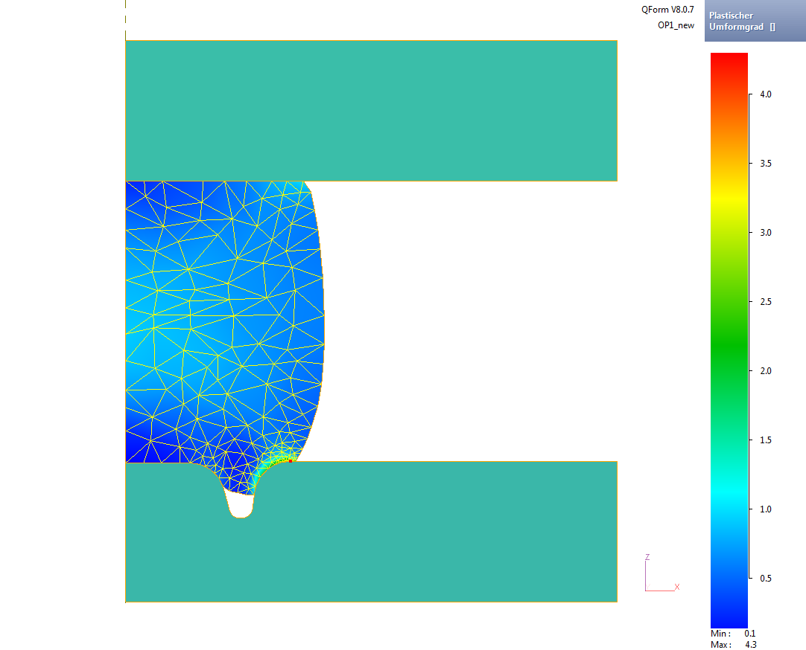 |  | Figure 5.4: Plastic strain of operation 1
 | 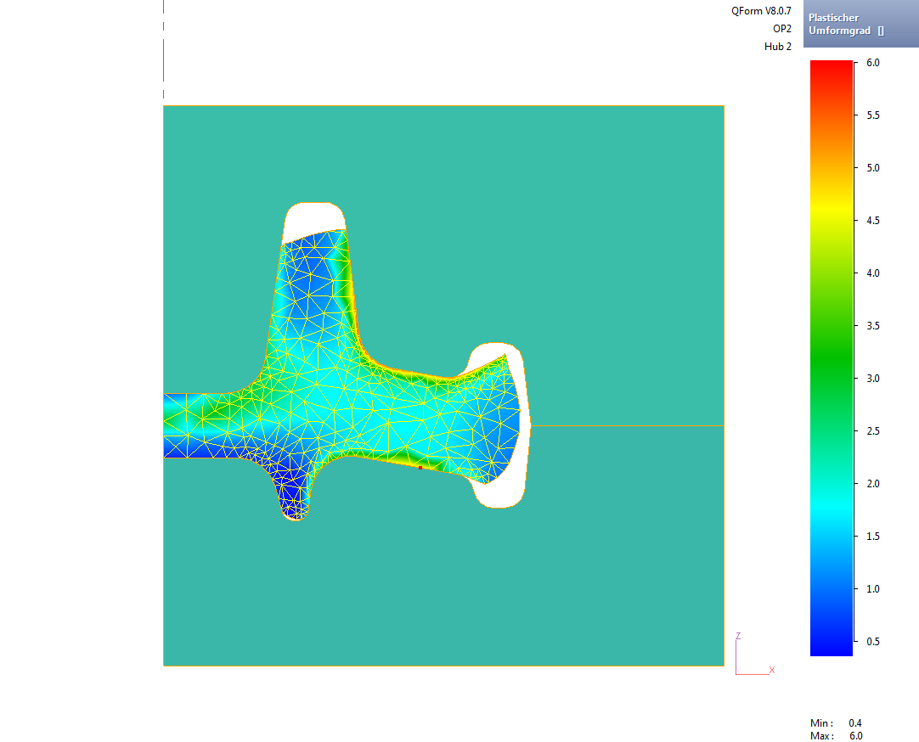 |  | Figure 5.5: Plastic strain of operation 2
 | 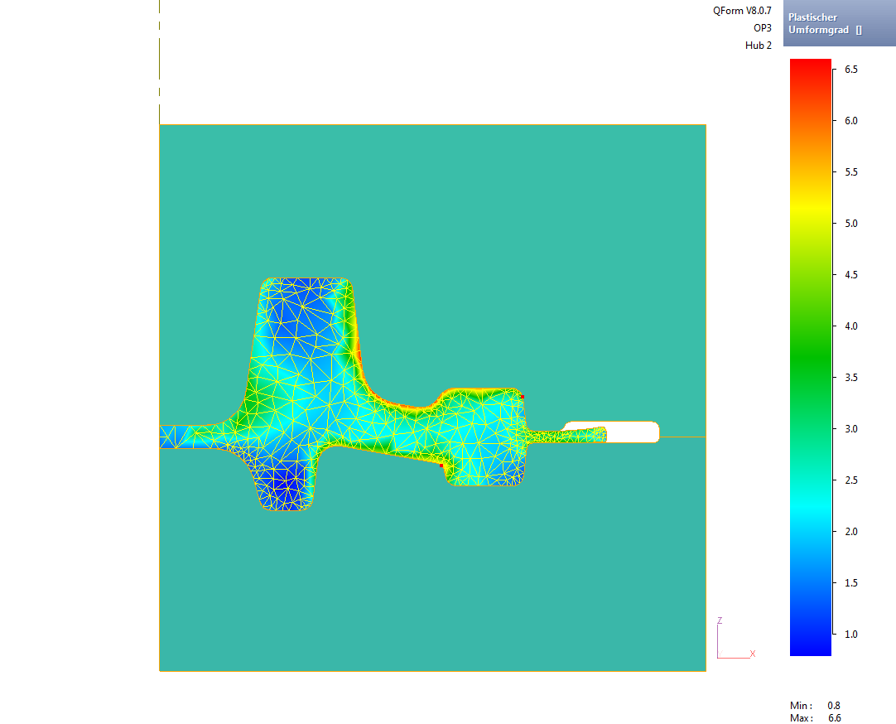 |  | Figure 5.6: Plastic strain of operation 3
Maybe, the wrinkle formation and the high plastic strain could have been reduced through a more intensive preforming operation or a further intermediate stage. Also, an optimization of the die at operation two may be a solution.
The force paths of the three steps are shown in the following figures. Operation one (see Figure 5.7) shows a relatively linear force path with a small inhomogeneity at its beginning. In this first area of the curve, the material flows into the engraving in order to form the centering.
In contrast, operation two shows a much more inhomogeneous path (see Figure 5.8). The “spikes” are a consequence of the die-filling process. The rest of the force path seems to be relatively linear.
The force path of operation three shows a big difference towards the previous steps (see Figure 5.9). In the beginning, the force jumps up, and after that, there is a constantly high force level. This high force can be explained by the filling process of the die. Towards the end, almost the complete surface of the die is in contact with the workpiece, so a very high force is needed.
 | 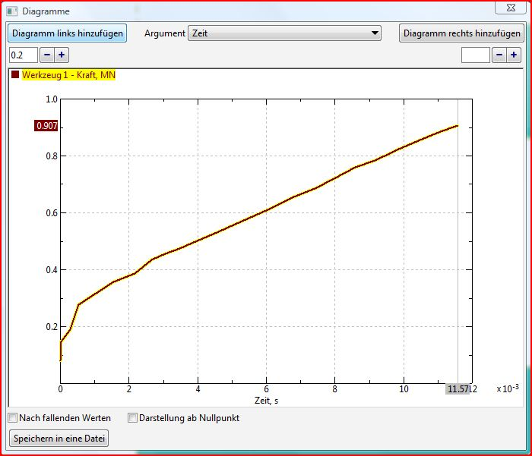 |  | Figure 5.7: Force path of operation 1
 | 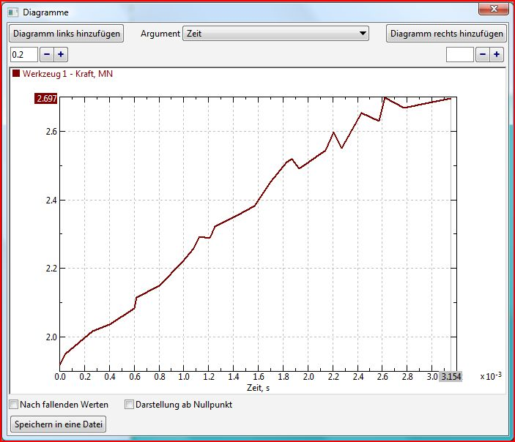 |  | Figure 5.8: Force path of operation 2
 | 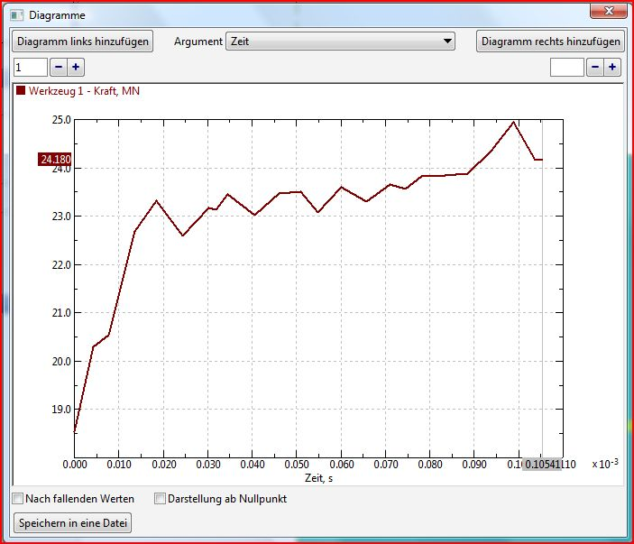 |  | Figure 5.9: Force path of operation 3

Conclusion
In this international students olympiad, a forging sequence for producing the raw part of a gear in three steps has been designed and simulated. The final design of the forged part is based on the given drawing of the machined gear.
It came true that the design of the forging dies is not perfect. The wrinkle formation may have been reduced through another iteration loop. Possible improvements could have been bigger radiuses at the edges of the second operation and a more intensive preforming in the first step.
Furthermore, a variation regarding the forging press (with another velocity path) may have brought other results. This measure would have influenced the contact time and also the tool wear.

