**The International Students Olympiad in Hot Bulk Forging Technologies**

*CODE 221*

1. Introduction:

Elaboration of forging technology of gear wheels and its optimization based on process simulation in the QForm v8 software.

2. Ordering Informations:

The size of the order - 20 000 pcs. Hot forging of 20 MoCr4 steel. Available forging equipment:

* 3 mechanical press 16 MN
* 2 steam hammers 2t, 50 kJ

3. Selection of the production method

The finished part weighs approx. 3.4 kg and it is axially symmetric. I chose forging process on mechanical press because of the fact that the part is relatively small so the available forging press is sufficient.

4. Determination of the forged part dimensions

I described the dimensions of forgings according to PN-86 / H-94301.

The difficulty of materials M1 (carbon content in the steel <0.65%, the amount of alloying elements <5%)

* Choosing of the material allowances for machining operations:

I choose sided allowance for machining based on the largest diameter (180,6 mm) amounting to 2.6 mm. It is assumed this value of allowances for each workpiece diameters.

|  |  |  |  |  |
| --- | --- | --- | --- | --- |
|  | Outer diameter | |  | Inner diameter |
| Final part diameter [mm] | 180,6 | 94,5 | 75 | 56 |
| Forged part diameter [mm] | 185,8 | 99,7 | 80,2 | 50,8 |

The forging diameters were increased by 1,025% due to thermal expansion.

For linear dimensions sided allowance for machining the largest dimension adopts 2mm for each machined surface.

|  |  |  |  |
| --- | --- | --- | --- |
| Final part dimensions [mm] | 54 | 21 | 20 |
| Forged part dimensions [mm] | 58,6 | 25,3 | 24,2 |

The forging diameters were increased by 1,025% due to thermal expansion.

* Determination of tolerance and limit deviations of forging dimensions:

Index the contents of shape S = m/mb, where m - weight, mb - mass of the solid described on forged part. S = 3,41kg/10,86kg = 0.31 (the degree of difficulty equal S2)

* Selection of the forging inclination

Forming on the forging press without ejectors.

|  |  |  |
| --- | --- | --- |
|  | Lower die | Stamp |
| Inner inclination | 9° | 6° |
| Outer inclination | 6° | 3° |

* + Selection of rays rounding

|  |  |  |
| --- | --- | --- |
|  | Lower die | Stamp |
| Outer | 2,5 | 4 |
| Inner | 4 | 6 |
| Crosssection change | 2,5 | 6 |

* + Determination of the bottom thickness:

The flat bottom. The average diameter ds = 46.6. The thickness of the bottom according to the norm is equal g = 5mm

5. Determination of flash dimensions and tools material

Tools material – H13HRC50

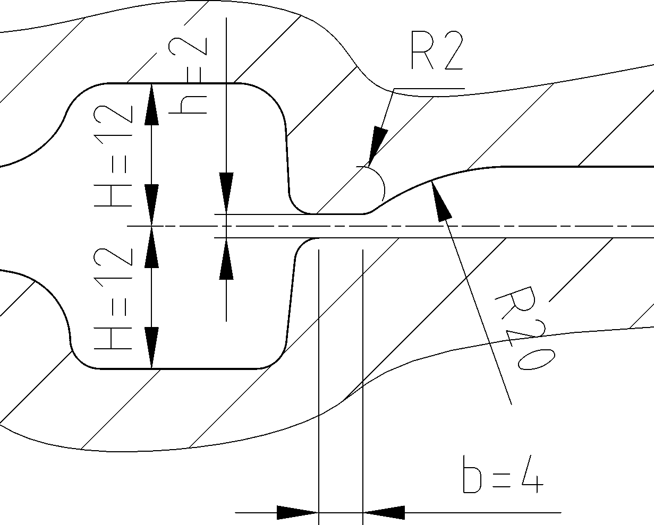

6. Determination of type and dimensions of the workpiece.

* + The volume of flash is calculated on the basis of the adopted shape
  + Vr=Fr*(lr+π*br) [cm^3], where  
    lr- the length of the flash at the periphery of the dividing plane  
    Fr=h*br – crosssectional area of the flash  
    br=γ*b - width of the flash  
    b – width of the groove  
    γ- factor determining the ratio of the width of the flash (1-2.5), depending on the complexity of the forging. It is assumed γ=1  
      
    br=1*4=4 mm  
    Fr=2*4=8mm^2  
    lr=587 mm  
      
    Vr=8*(587+3,14*4)=5 cm^3
  + Volume of the workpiece  
      
    Vw=(Vod+Vr)*100/(100-z), where:  
    Vod- volume of the forged part Vp=637 cm^3  
    Vr- volume of the flash Vr=5 cm^3  
    z – the amount on scale losses, It is assumed z=1%  
    Vw=(637+5)*100/(100-1)=649 cm^3

Vws - workpiece volume used in the simulation Vws=642 cm^3 (z=0, because it is impossible to simulate the scale losses)

* + Workpiece: round bar, diameter Ø 100 i 84. induction heating to 1200 °C.

7. Simulation parameters

* + Workpiece temperature: 1200 °C,
  + Forging in two operations - shaped upsetting and die forging. The upsetting is conducted to remove the scale and obtain the initial shape of final part
  + Environment temperature: 50 °C
  + Tools material: H13HRC50
  + Workpiece material: 20MoCr4
  + Cooling in tools between blows: 2s.

8. Load changing graphs and distribution maps of stress and strain in forged part

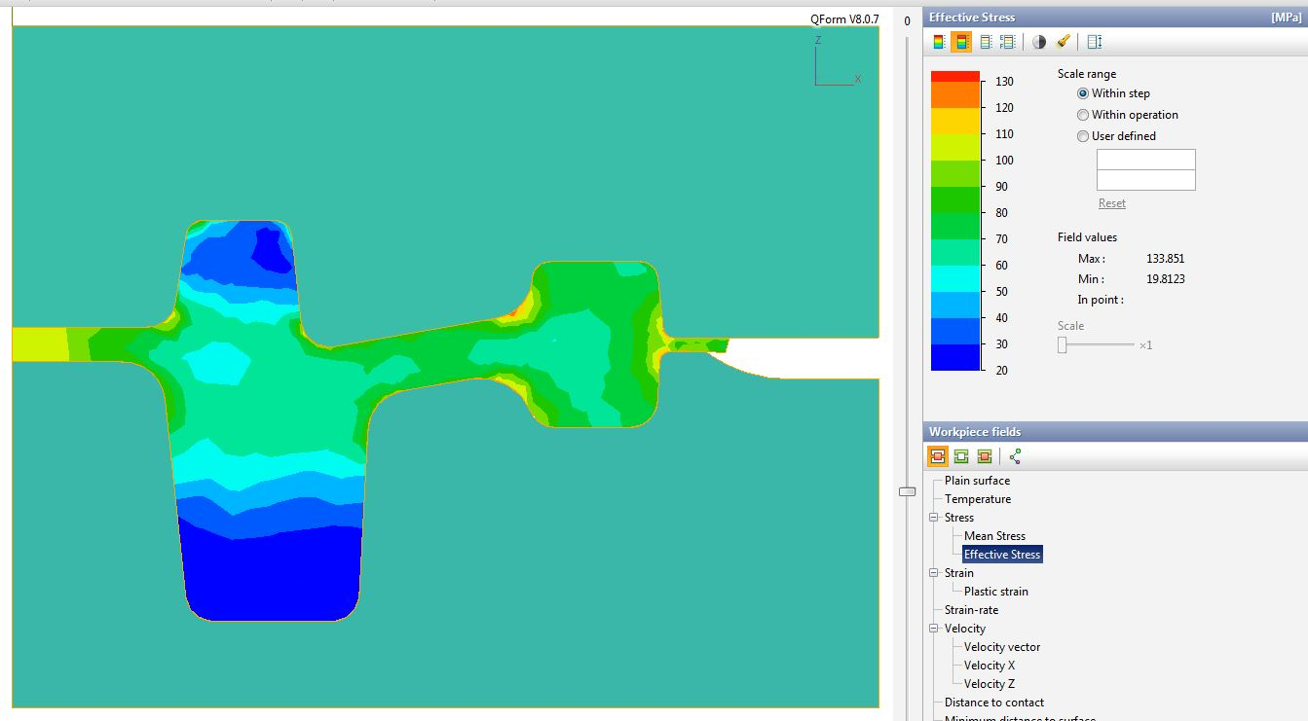Effective stress distribution in the forged part at the final stage of forming

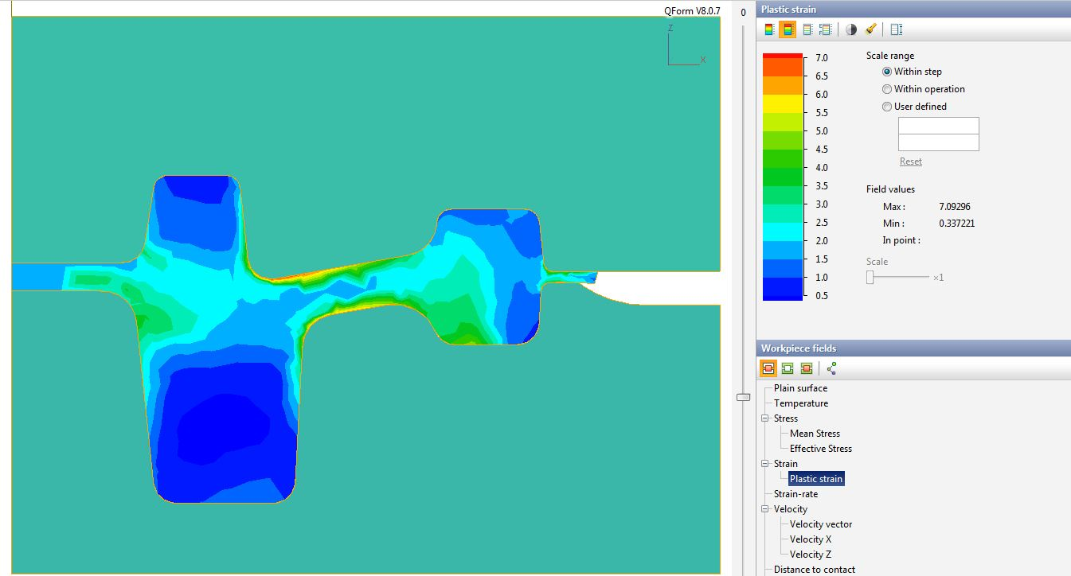Plastic strain distribution in the forged part

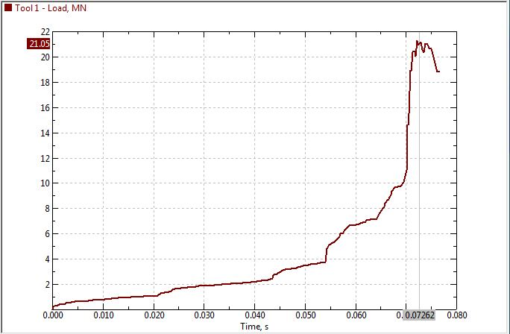Load changing in the upper die

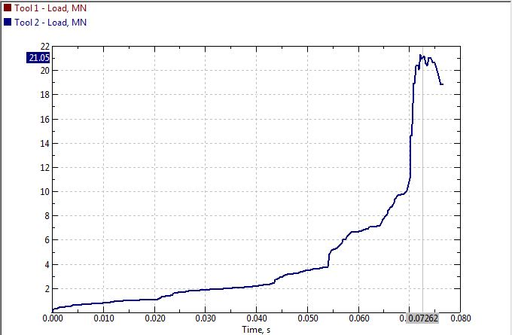

Load changing in the lower die

9. Summary:

* Selection of workpiece dimensions was completed taking into account the minimizing of the material allowances,
* The obtained load exceeds the capabilities of the available equipment. Load reduction is possible by further shape optimization or addition intermediate forging operations.
* Effective stress in the forged part reaches relatively low values
* Temperature distribution in the forged part does not fall at less than 1100 degrees, which is preferable.