

**FEA SIMULATON OF METAL FORMING USING**

**OLGA I. BYLYA**

**MANOJ K. SARANGI**

ASHISH AGRAWALA

3rd Year MECHANICAL ENGG.

ITER, S’O’A UNIVERSITY



***PROBLEM STATEMENT-***

To prepare the given product by forging to the given dimensions.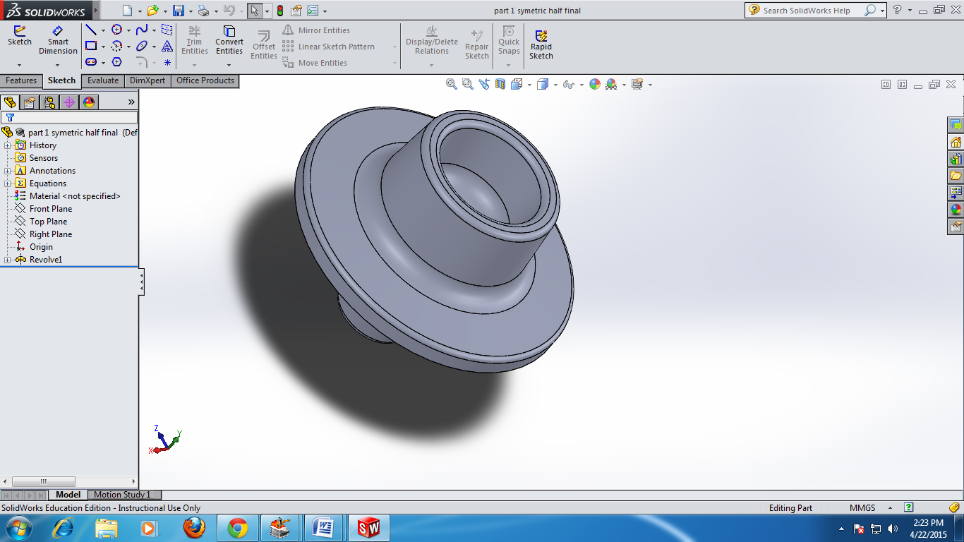

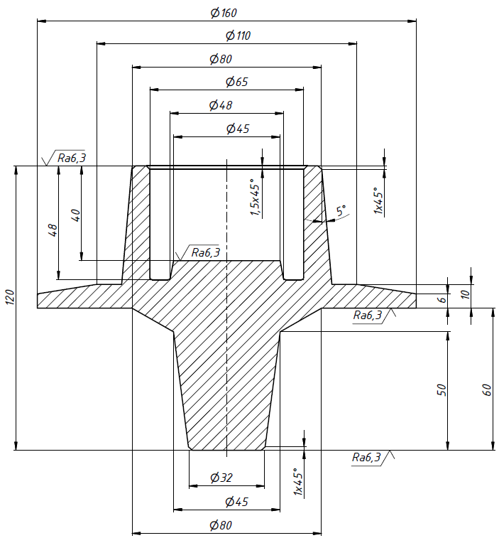

Part after machining

***PRELIMINARY CALCULATIONS AND CONSIDERATIONS***-

* Work piece material: Carbon Steel C45(1.0503)
* weight of the forged product=5.1008 kg
* volume of the product after machining as calculated from solid works=473717.47
* volume of the forged product as calculated from solid works= 649684.89 cubic millimeters
* allowance=27%

***MATERIAL PROPERTIES (C 45, 1.0503):***

|  |  |
| --- | --- |
| Density | 7514Kg/(m^3) |
| Thermal Conductivity | 26.8 W/(m K) |
| Specific Heat | 637.4 J/(Kg K) |
| Melting Temperature | 1539 °C |

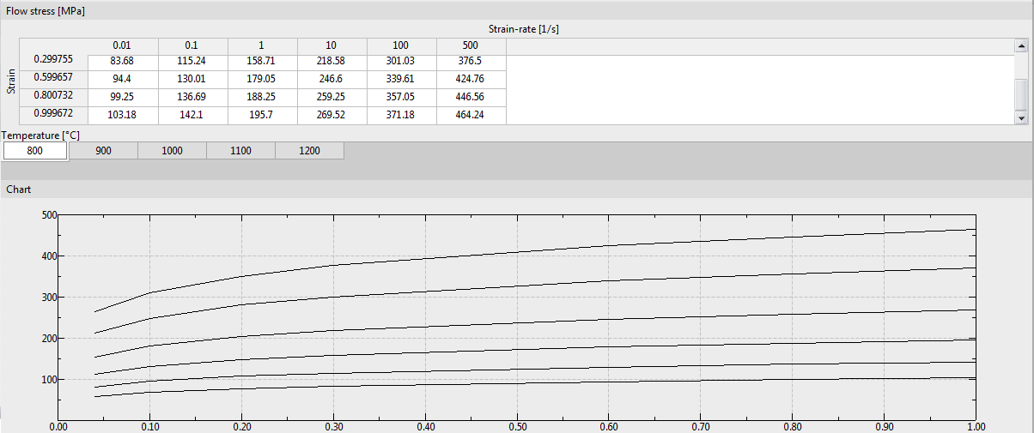

It can be observed from the above chart that forging of this material shows explicit results within a temperature range of 800°C to 1200°C. Therefore, assuming the initial temperature of the billet to be 1000°C.

***Determining the size of the initial billet***-

We take as a figure describing the basic cylinder with its axis perpendicular to the end faces. The height of the billet to is diameter ratio should be < 3.0 to avoid buckling. Thus, taking height to the diameter ratio, m =2.2, thus,

$$\left\{\begin{matrix}\frac{πd_{заг}^{2}}{4}l_{заг}=V_{заг}, \\ \frac{l_{заг}}{d_{заг}}=m;\end{matrix}⇔\left\{\begin{matrix}d_{заг}=\sqrt[3]{\frac{4V_{заг}}{πm}}, \\ l_{заг}=\frac{4V_{заг}}{πd_{заг}^{2}};\end{matrix} \right.\right.⇒\left\{\begin{aligned}d_{заг}=\sqrt[3]{\frac{4*649684.89}{π⋅2.2}}=72.17 мм→72мм \\ l_{заг}=\frac{4*649684.89 }{π⋅{72.17}^{2}}=158.81 мм→160мм\end{aligned} \right.$$

***Design drawings for the manufacture of forging die-***

Assigning basic allowance for machining forgings,

For the diameter basic size=160mm.It lies in the diameter step of 120mm and 180mm.

Thus D= √(120*180)= 146.97mm.

The fundamental deviation for h7=0mm and the value of tolerance is given by 400i where

C:\Users\mech20\Desktop\tol.png µm

Thus substituting the value of D=146.97mm, we get,

i=2.522 µm and tolerance for IT14 =400i=400*2.522*10^ (-3) =1.009mm

Similarly, calculating the tolerance values for the rest of the dimensions we get-

|  |  |  |  |
| --- | --- | --- | --- |
| Table. 1. Basic allowances forgings | | | |
|  | Size, mm | Roughness, micron | The basic allowance, mm |
| Diameters | 160 | 12.5 | 2.0 |
| 110 | 12.5 | 1.9 |
| 80 | 12.5 | 1.7 |
| 65 | 12.5 | 1.7 |
| 48 | 12.5 | 1.7 |
| 45 | 12.5 | 1.7 |
| 32 | 12.5 | 1.5 |
| Thickness | 10 | 12.5 | 1.5 |
| 10 | 6.3 | 1.8 |
| 6 | 12.5 | 1.5 |
| 6 | 6.3 | 1.8 |
| Length | 120 | 6.3 | 2.3 |
| 60 | 6.3 | 2.0 |
| 50 | 12.5 | 1.7 |
| 50 | 6.3 | 2.3 |
| 48 | 12.5 | 1.7 |
| 48 | 6.3 | 2.0 |
| 40 | 6.3 | 1.8 |

Additional allowance offset the parting surface of the stamp for forgings weighing 5.1008 kg with a flat surface of the connector and accuracy class T4 acc. [1 , Tab. 4 ] is 0.3 mm.

Additional allowance for deviation from linearity for forging parts with the largest size of 160 mm and an accuracy class T4 is 0.4 mm.

Nominal diametrical size of forgings:

$$160+\left(2.0+0.3+0.4\right)*2=165.4 мм;$$

$$110+\left(1.9+0.3+0.4\right)*2=115.2 мм;$$

$$80+\left(1.7+0.3+0.4\right)*2=84.8 мм;$$

$$65+\left(1.7+0.3+0.4\right)*2=62.6 мм;$$

$$48+\left(1.7+0.3+0.4\right)*2=52.8 мм;$$

$$45+\left(1.7+0.3+0.4\right)*2=49.8 мм;$$

$$32+\left(1.5+0.3+0.4\right)*2=36.4 мм.$$

The nominal dimensions of forging thickness:

$$10+\left(1.8+0.3+0.4\right)*2=15 мм;$$

$$6+\left(1.8+0.3+0.4\right)*2=11 мм.$$

The nominal dimensions of forgings in length:

$$120+\left(2.3+0.3+0.4\right)*2=126 мм;$$

$$60+\left(2,3+0,3+0,4\right)-\left(2,0+0,3+0,4\right)=60,3 мм;$$

$$50+\left(2.3+0.3+0.4\right)-\left(1.7+0.3+0.4\right)=50.6 мм;$$

$$48+\left(2.3+0.3+0.4\right)-\left(1.7+0.3+0.4\right)=48.6 мм;$$

$$40+\left(2.3+0.3+0.4\right)-\left(1.8+0.3+0.4\right)=40.5 мм.$$

Assign tolerances size forgings acc. [1, Tab. 8]

|  |  |  |  |
| --- | --- | --- | --- |
| Table. 2. tolerances and tolerances size forgings | | | |
|  | Size forgings, mm | Tolerances, mm | Tolerance, mm |
| Diameters | 165.4 | $$\begin{matrix}+2.4 \\ -1.2\end{matrix}$$ | $$3.6$$ |
| 115.2 |
| 84.8 | $$\begin{matrix}+1.0 \\ -1.8\end{matrix}$$ | $$2.8$$ |
| 69.8 |
| 52.8 |
| 49.8 |
| 36.4 | $$\begin{matrix}+1.6 \\ -0.9\end{matrix}$$ | $$2.5$$ |
| Thickness | 15.0 |
| 11.0 |
| Length | 125.0 | $$\begin{matrix}+2.1 \\ -1.1\end{matrix}$$ | $$3.2$$ |
| 60.3 | $$\begin{matrix}+0.9 \\ -0.5\end{matrix}$$ | $$1.4$$ |
| 50.6 |
| 48.6 |
| 40.5 |

***GEOMETRY PREPARATION-***

The forging could be done in 3 operations. But keeping the cost of the dies in account, the forging was prepared to be done in 2 operations. Namely,

The forging was done in two steps-

1) Up-setting

2) Final forging

1) **Up-setting-**

The tools used for this operation are shown below-

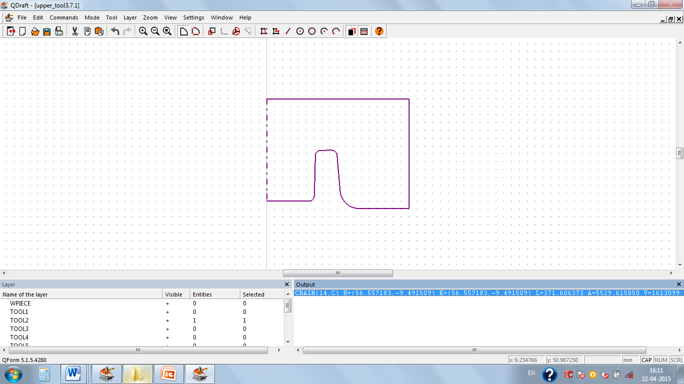 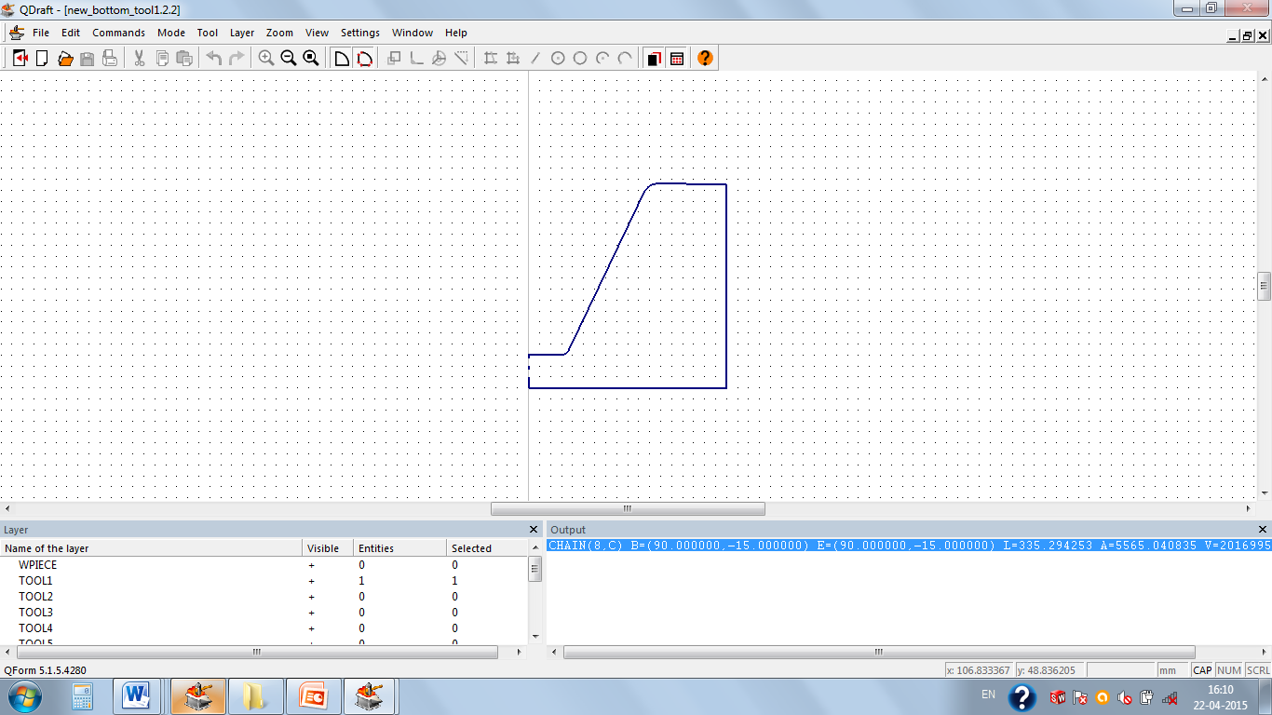

Upper die used in 1st operation Bottom die used in 1st operation

In this operation, the billet was forged to obtain an approximate shape of the final forged part using the dies as shown in the figure. The die at the left( shown in violet) is the upper die and the die as the right( shown in blue) is the bottom die used in operation 1.

2) **Final forging-**

In this operation, the forged part obtained from the first operation was further forged in another die to obtain the required shape of the product. This is the last operation performed in order to get the product.

Here, the die at the left (shown in violet) is the upper die and the die as the right (shown in blue) is the bottom die as used in operation 2.

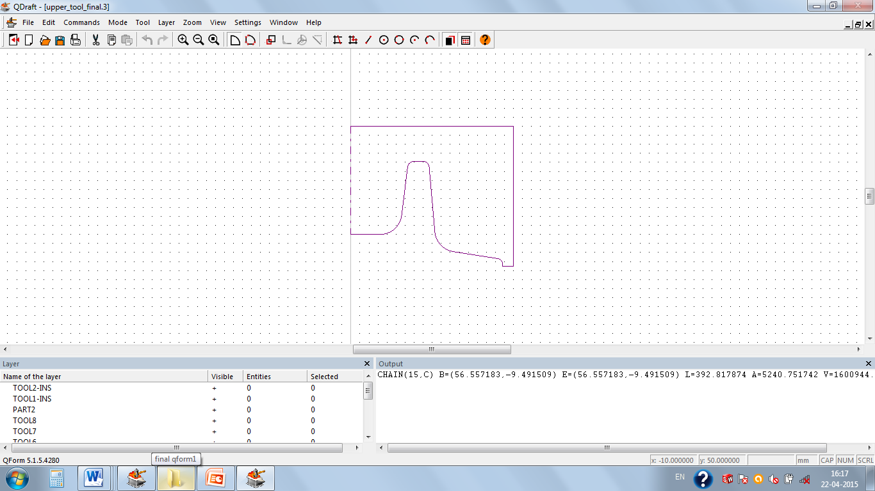 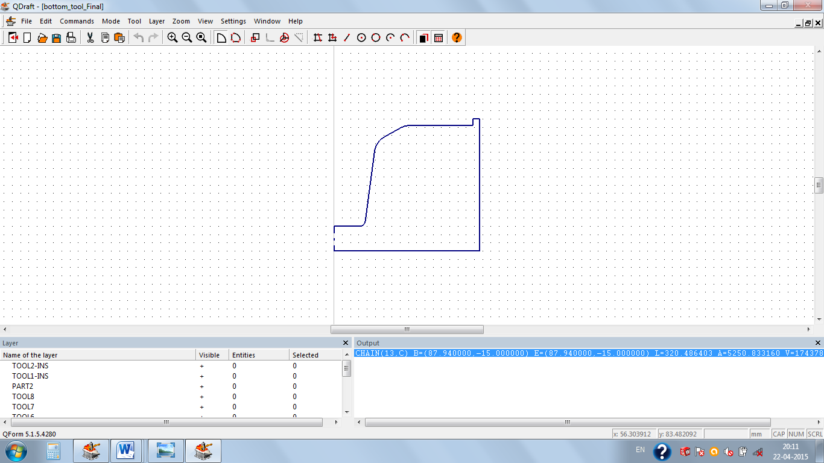

Upper die used in 2nd operation Bottom die used in 2nd operation

***FLOWCHART OF PROCESS FOLLOWED-***

***AFTER SIMULATION-***

* **1st Operation- *Upsetting***

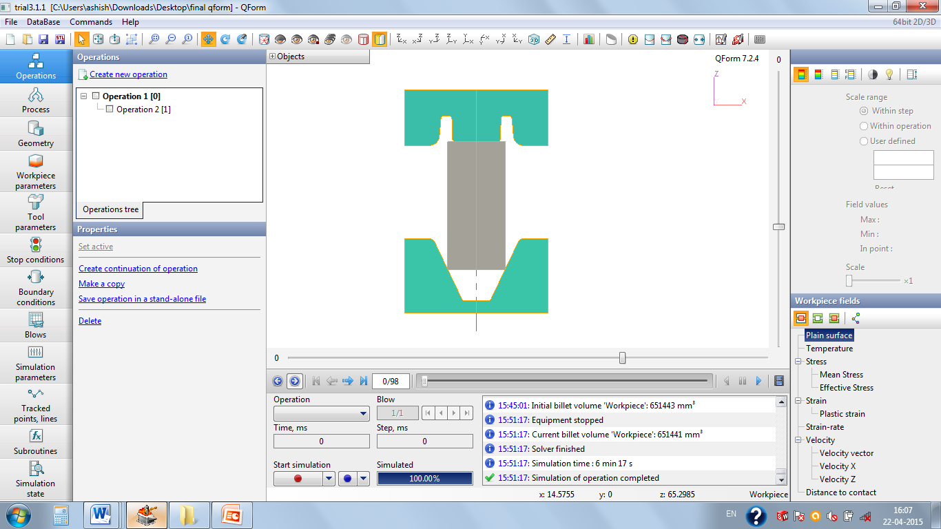 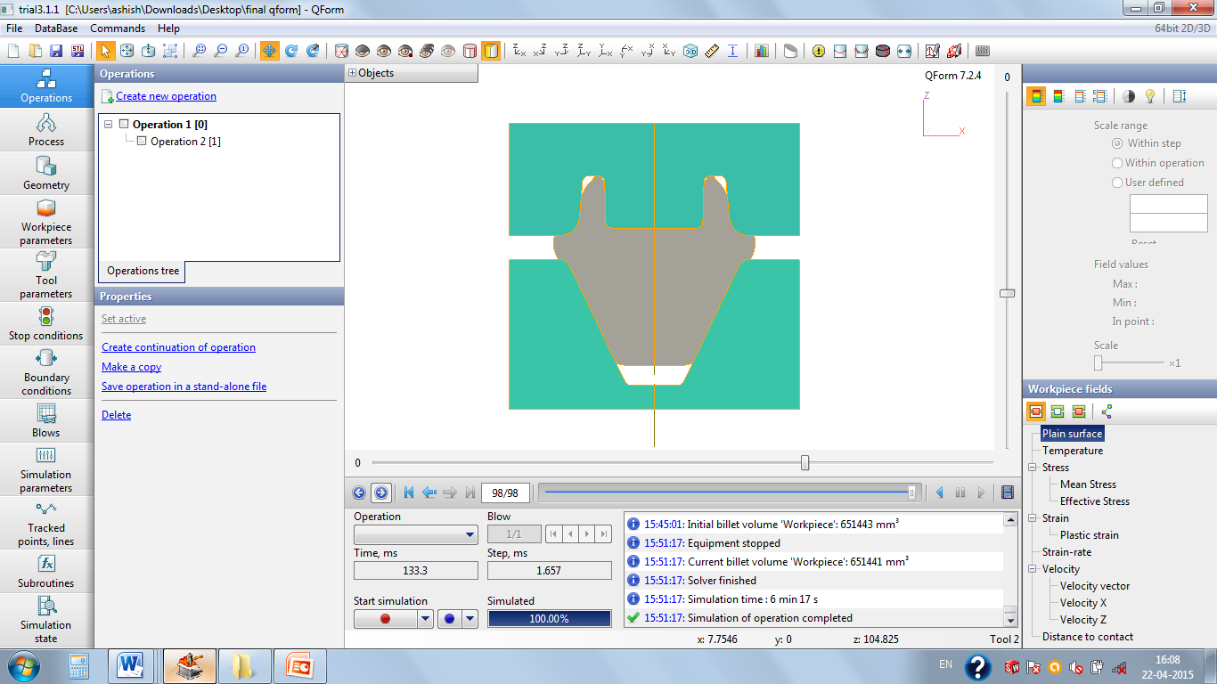

At Beginning of Upsetting- At End of Upsetting-

In this operation the billet is upsetted and brought to the approximate shape of the part.

The tools are tapered for the easy removal of the forged part and avoid the damage of the die or the forged part.

* **2nd Operation- final forging** ( to obtain the required size of the part)

After the completion of the upsetting of the billet, the part thus obtained is done the final forging. Directly making the die of the required dimension caused incomplete filling of the die at the edges. So, this operation was performed so as to avoid the unwanted defects and under fillings. In this operation, final piercing is done and the final forged part is obtained.

We have provided provision for flash only in the last operation and the scales produced on the surface will be eliminated by machining. The figures below show the state of the forged part as the start and end of this operation.

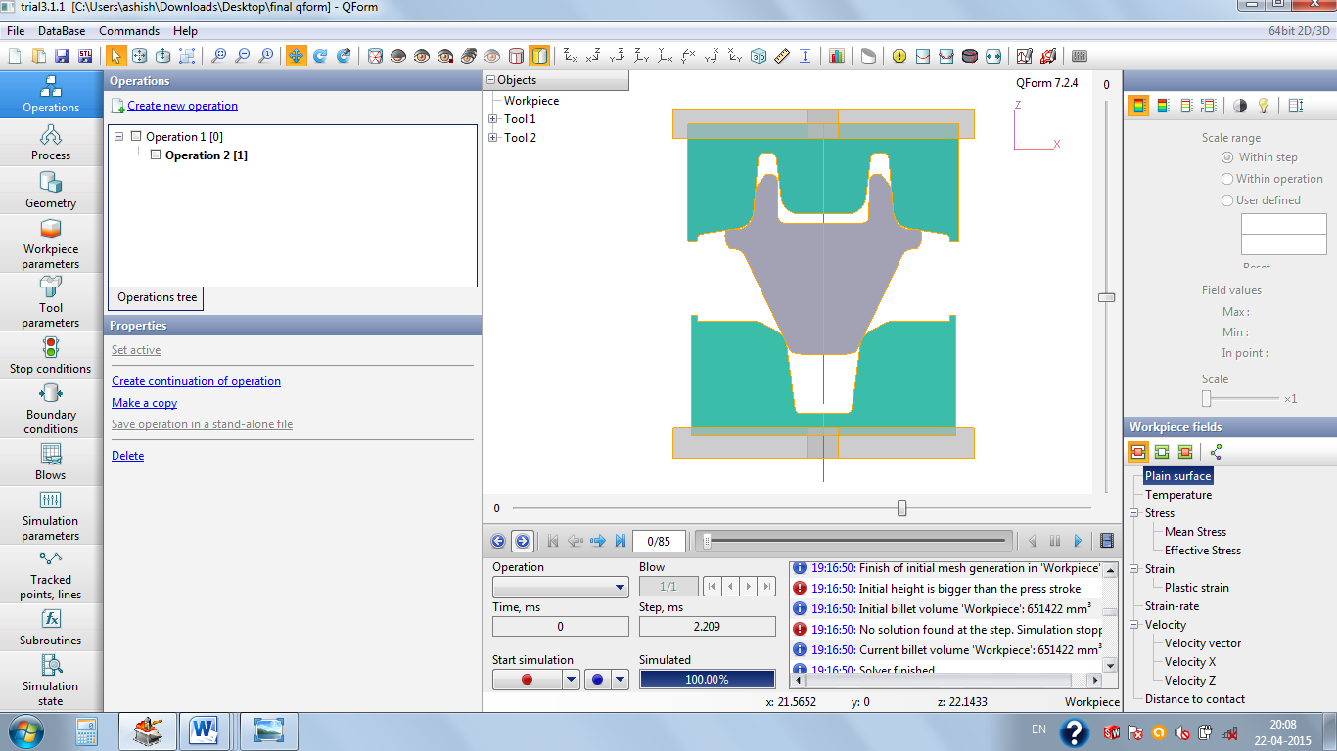 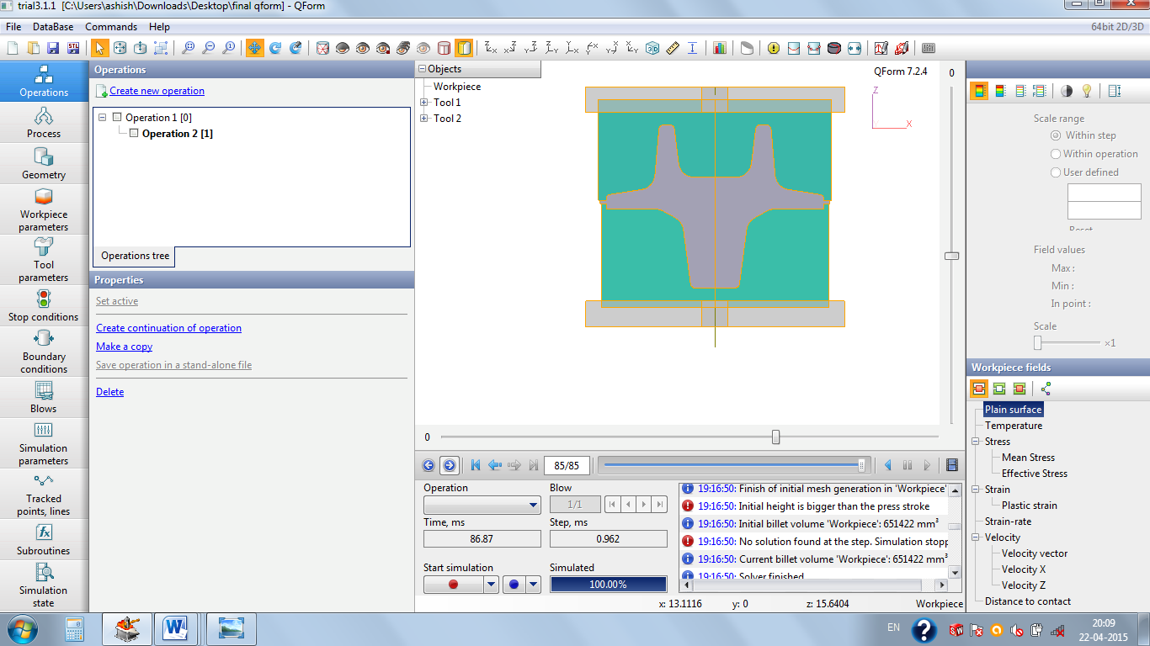

At Beginning of the 2nd operation At the end of 2nd operation

***SIZE OF THE FORGED PART AFTER COMPLETION OF ALL SIMULATIONS-***

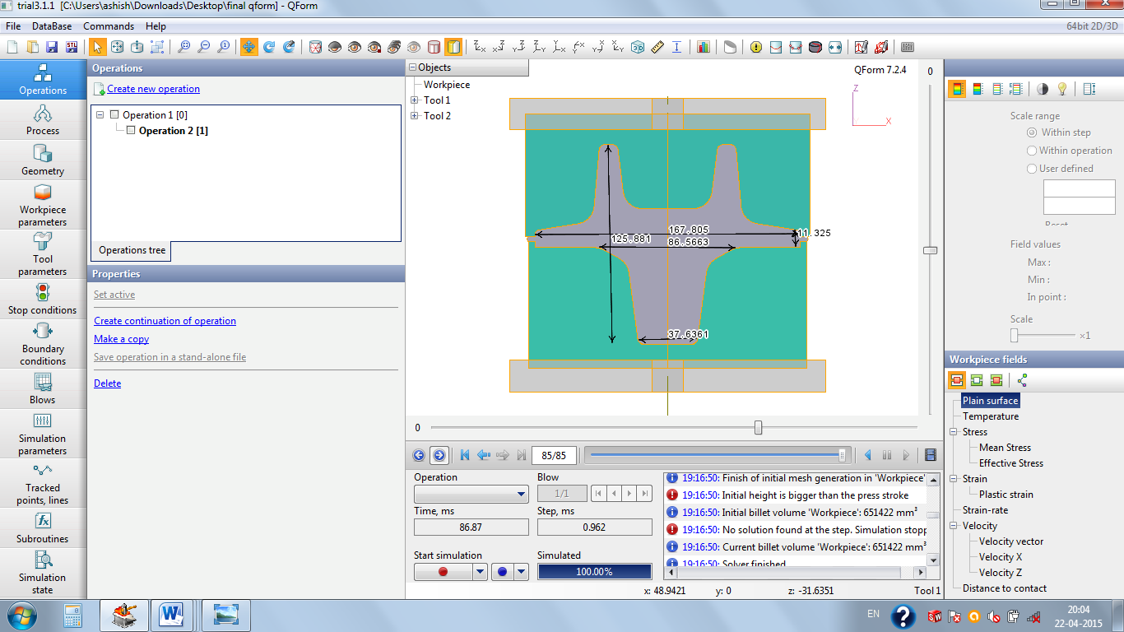

The product thus obtained after completion of all the operations is shown. The dimensions of the final product is shown above.

***PRELIMINARY OBSERVATIONS-***

***Choice of drive-***

Since the use of crank press was recommended, so taking a press of 6.3 MN (standard from database of QForm) was taken for forging.

***STATEMENT OF THE PROBLEM IN QFORM-***

|  |  |
| --- | --- |
| Material of Work piece- | Carbon Steel C45 (1-0503) |
| Work piece Temperature | 1000°C |
| Type of Forging- | Hot Forging |
| Tool Material- | 5140 HRC39 |
| Tool Temperature- | 200°C |
| Lubricant- | Graphite and water |
| Press Used- | 6.3MN Crank press |
| Ambient Temperature- | 20°C |
| Maximum mesh size (in Work piece)– | 1.0 |

***SIMULATION ANALYSIS-***

**TEMPERATURE ANALYSIS-**

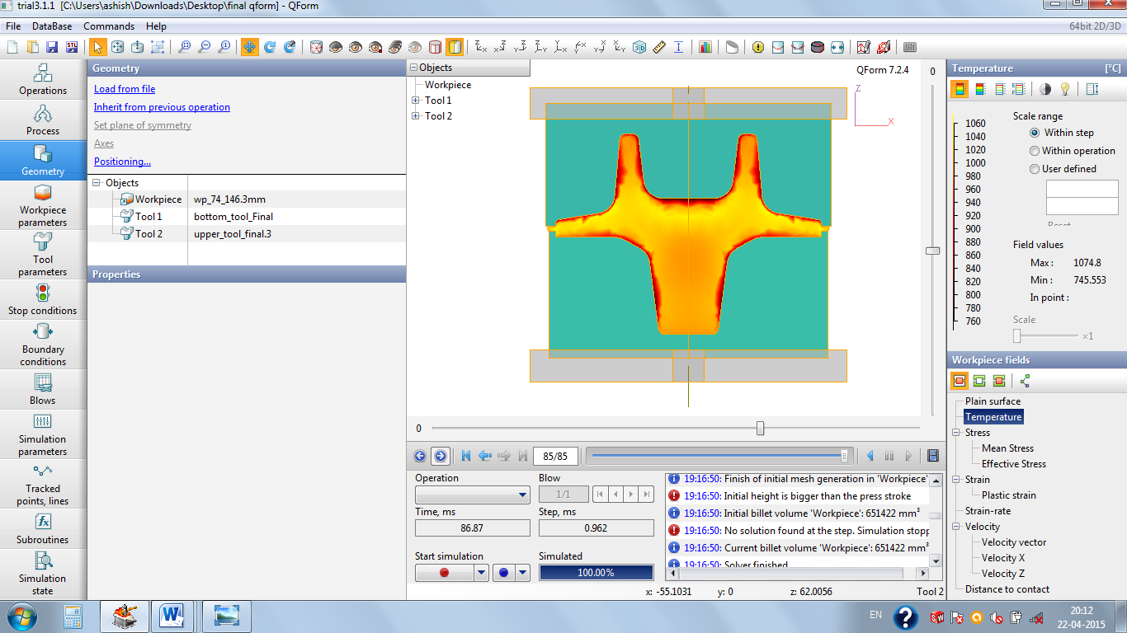

As the tool is at lower temperature as compared to that of the work piece so the contact surface have higher rate of cooling as that in the inner areas. So, its temperature decreased at the periphery of the work piece.

Initial work piece temperature was 1000°C and the temperature after forging raised to a maximum value of 1074.8°C.

**STRESS AND STRAIN ANALYSIS-**

**Plastic strain-**

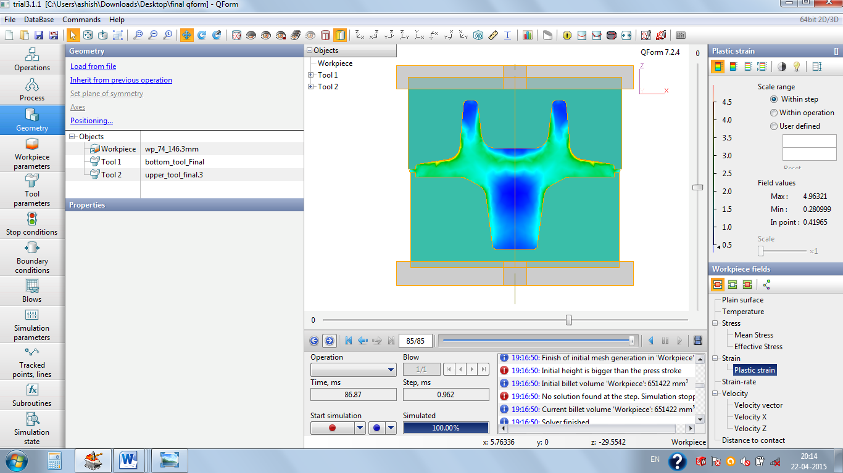

The plastic strain reaches to a maximum value of 4.5 to a minimum value of 0.280999. As major portions of the part where the strain value is high will be machined thus eventually decreasing the plastic strain to almost 0.5.

**STRESS-**

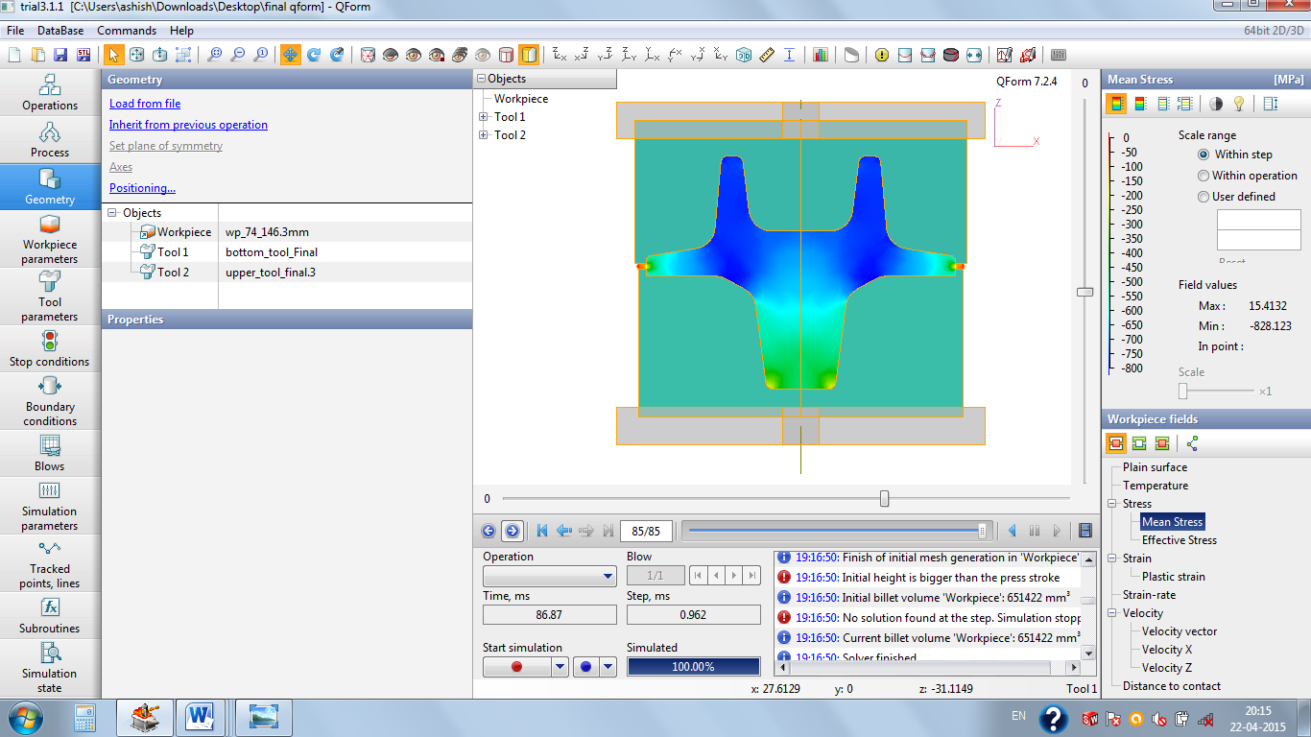

The mean stress is negative throughout the work piece except for some the portions. But the portions where the mean stress is nearly equal to zero will be machined. Thus, the tri-axiality factor is negative. So, chances of failure of the material are very less as the stress would be compression or hydrostatic compression in nature.

***EFFECT OF LUBRICATION-***

* Although viscous glasses are often used in hot extrusions, hot working is often done without lubrication.
* Tool life is shortened due to heating, the presence of abrasive scales and lack of lubrication.
* Results in poor surface finish and loss of precise gauge control.

The following show the hot forging under same conditions of temperature and loading-

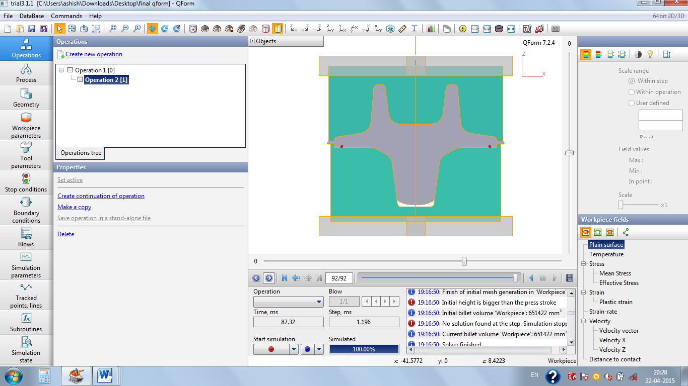 

Unlubricated Lubricated with graphite and water

With no lubrication, the die is more unfilled at the corners under same loading and environment conditions. To avoid such defects lubrication is recommended. As molten glass is more costly than graphite-water so use of graphite-water is recommended.

***FLOW LINES AND DEFECT ANALYSIS****-*

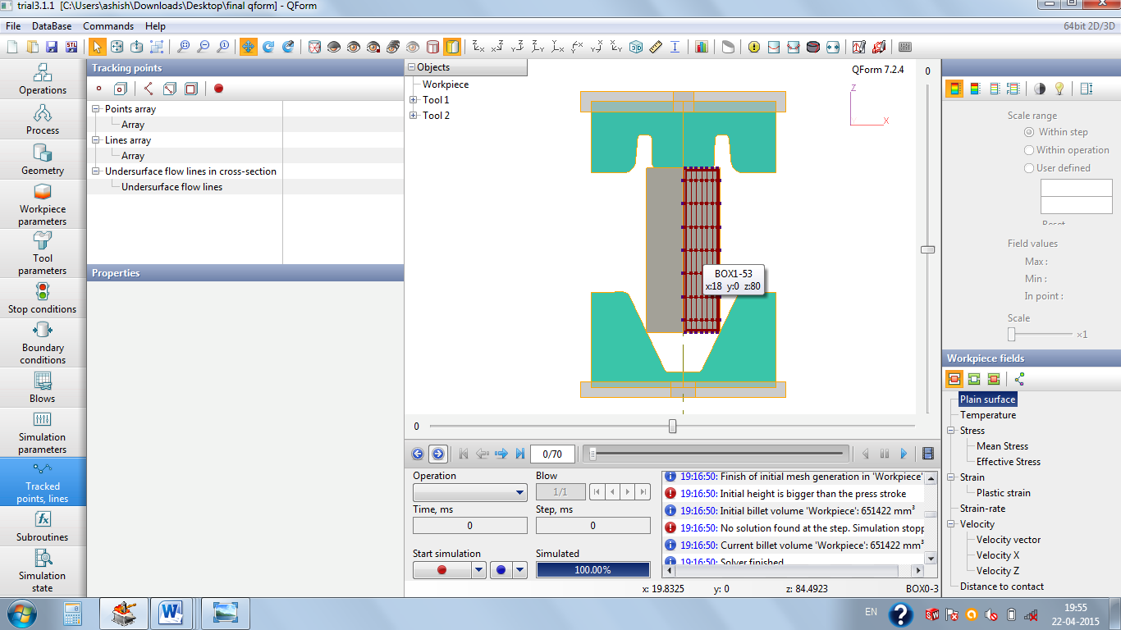 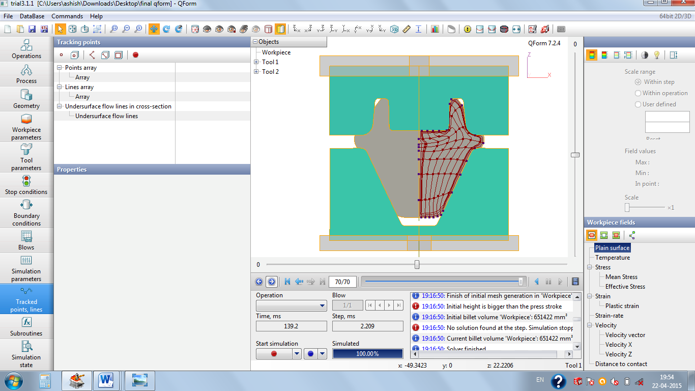

Start of up-setting operation End of upsetting operation

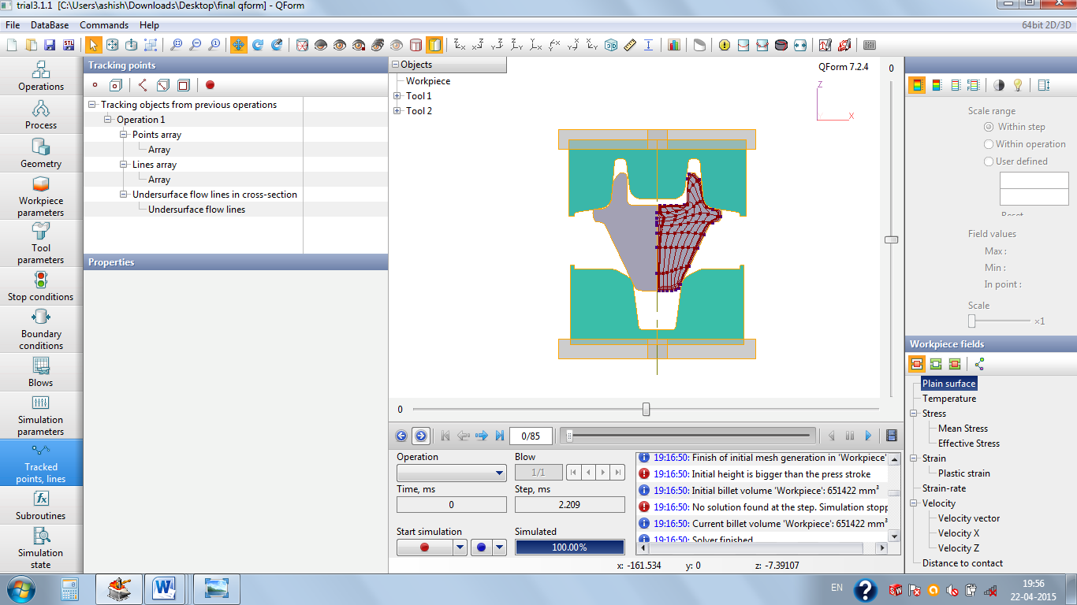 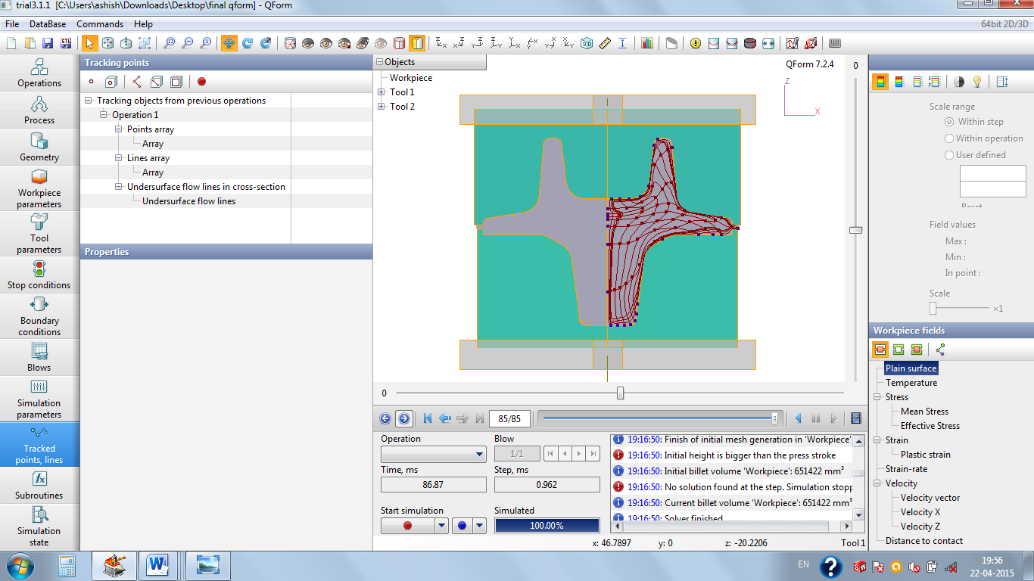

Start of final-forging operation End of final-forging operation

The flow lines and various points were tracked in order to estimate the flow of material. The presence of the flow lines shows the uniformity of the grain alignment. Further it enables to predict the defects such as folding of material or overlapping of metals during the course of operation, if present.

***CONCLUSION-***

After many attempts and modifications an acceptable solution has been achieved. Provision has been made for flash in the last operation.

***SCOPE FOR FURTHER IMPROVEMENT-***

* Lubricants play a vital role. So the simulation by taking other lubricants may improve the plastic strain and mean stress.
* The temperature of the work piece was taken to be 1000°C in the simulation. Better results may be obtained if higher temperature of the work piece is taken.
* Choice of billet of larger diameter and shorter height may further give better results.
* The better design of the tools may further give better results.
* Choice of the press may further improve the results obtained.