**The International Students Olympiad in Hot Bulk Forging Technologies**

*CODE 236*

**Development of forged part drawing.**

The forged part drawing is developing by the detail drawing, following the GOST 7505-89 (Russian standard for hot forging) instructions. The development is started from defining structural characteristics of forged part: tolerance grade, group of steel, degree of complexity and configuration by a parting line of dies.

**The tolerance grade** ischosen from 5 possible grades: ***T1***, ***T2, T3, T4,*** and ***T5***.

The tolerance grade ***T5*** assumed for steam hammers following the GOST 7505-89 recommendations *[2].*

Then an estimated mass of forged part is calculated by the formula [1, p. 3]:

$$G_{F.P.C.}=G_{D}∙K_{c},$$

$$G_{F.P.C.}=2.7∙1.5=4.05 kg.$$

The detail is made of steel 20XGT (20XГT). The group of steel is M2.

The degree of complexity is determined using the formula:

$$C=\frac{V_{F.P.C.}}{V_{F}}$$

$$C=\frac{651913.2}{1382607.5}=0.47.$$

The degree of complexity is C2.

The configuration of the parting line for our forged part is plain.

Then find the initial index using the determined tacks.

The initial index – II 15.

Allowances for machining have specified for the determined II 15.

Allowances for machining

|  |  |  |  |
| --- | --- | --- | --- |
| Dimension for the allowance specification, mm | Basic allowance | Additional allowance | Final dimension |
| Ø180.6 | 2.2 | 0.6 | Ø186 |
| Ø94.5 | 2.3 | 0.5 | Ø100 |
| Ø 56 | 1.9 | 0.3 | Ø51.5 |
| Ø150 | 2.0 |  | Ø146 |
| Ø75 | 1.9 |  | Ø79 |
| 54 | 2.0 | 0.6 | 59 |
| 20 | 1.7 |  | 23.5 |

There are no vertical surfaces on the hammer forged parts. The lateral surfaces have an inclination that is called the draft. Drafts are necessary for easy removal of forged part from the die forgings. The draft for outer surface is 7° and for the inner – 10°.

The edges of forged part are rounded with radii which are called the forming radii. The forming radii are divided on the outer and inner.

The outer radii are looking up in tables and their value depending on the mass of forged part and depth of the die impression. The outer radius of our forged part is 2.5 mm.

The inner radius is considered using the formula:

$$R_{inner}=\left(3÷4\right)r_{outer}$$

where ${ R}_{inner}$– is the inner radius; $r_{outer}$– outer radius.

In this case, it is equal to 7.5 mm.

The cavities are separated by a flat film, if D ≤ 100 mm and film with a brace will be implemented for larger D. The D = 33.4 mm for our forged part, so the film is flat.

The thickness of the film is determined by the formula:

$S=\left(0.7÷0.8\right)\sqrt{D}$,

$S=\left(0.7\right)\sqrt{51.5}=5.02 mm$.

Development of the forged part

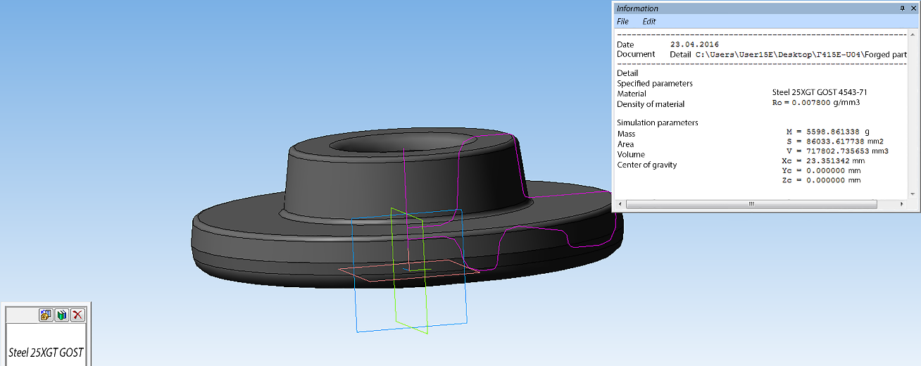

The mass of the forged part is within the selected range, consequently, it is considered correctly.

Dimensional tolerances of forged part

|  |  |  |
| --- | --- | --- |
| Dimension | Upper deviation | Lower deviation |
| Ø186 | +2.7 | -1.3 |
| Ø100 | +2.1 | -1.1 |
| Ø51,5 | +1.1 | -2.1 |
| Ø146 | +1.2 | -2.4 |
| Ø79 | +2.1 | -1.1 |
| 59 | +2.1 | -1.1 |
| 23.5 | +1.8 | -1.0 |

The mismatch allowance by the parting line of the die is up to 0.6 mm.

The remaining flash tolerance is up to 1.0 mm.

The misalignment tolerance of tacks is assumed up to 0.13 mm.

The coaxiality tolerance of punched holes in the forged part is assumed up to 2.0 mm.

Difference tolerance on camber, flatness, straightness for plain surfaces is assumed up to 1.0 mm.

The radial runout tolerance of cylindrical surfaces is assumed to equal to 2.0 mm.

**Calculation of dimensions of the forged part.**

The volume of the workpiece is made up of the volume of forged part $V_{F.P.}$, flash $V_{f}$, gutter ridge $V_{g.r.}$ and iron loss $V_{i.l.}$.

The values $V_{F.P.}$ and $V_{g.r.}$ may be calculated by using the drawing of forged part: $V_{g.r.} = 8818 {mm}^{3}, V_{F.P.}=717802.7 {mm}^{3}.$ The iron loss in the direct-fired furnaces is about 1.5 %. Thus, the final formula for calculation of the workpiece volume looks like:

$V_{wp}=1.015\left(V_{F.P.}+V_{g.r.}+V_{f}\right)$,

The flash volume is calculated by the following expression:

$V_{f}=ξ∙∏∙S_{g}$,

where $V_{f}$– is the flash volume; $ξ$– is the coefficient of gutter fullness is selected of 0.5; $S_{g}–$- is the cross-section of the gutter equal to 2.01 cm2 ; – is the perimeter of the gutter by the gutter center of gravity.

The mass of our forged part is more than 3 kg, the flash center of gravity follows the contour of forged part in the parting line of dies, that is the circumferential diameter of 186 mm. This implies that the perimeter of gutter will be equal to the perimeter of the circle:

$∏=πd=3.14∙186=584.04 (mm)$.

Now define the volume of flash:

$V_{f}=ξ∙∏∙S_{g}=0.5∙584.04∙201=58696 ({mm}^{3})$.

Thus, we have all the data necessary to determine the volume of the workpiece while accounting for iron loss:

$V_{wp}=1.015\left(V_{F.P.}+V_{g.r.}+V_{f}\right)=1.015\left(717802.7+8818+58696\right)=797096.5 ({mm}^{3})$.

The round forged parts are stamped in the butt end of cylindrical workpieces. Consequently, it is necessary to find the diameter $d_{billet}$ and length $l_{billet}$ of the workpiece.

Dimensions determined by the volume and relative parameter m. The estimated diameter is calculated as follows:

$$d_{wp}^{'}=1.08\sqrt[3]{V_{wp}/m} ,$$

where $V_{wp}$– is the volume; $d_{wp}^{'}$– is the estimated diameter; m – is the relative parameter (m = 2).

It will be equal to

$d_{wp}^{'}=1.08\sqrt[3]{V_{wp}/m}=1.08\sqrt[3]{797096.5/2}=79 (mm)$.

The dimension of a standard profile $d_{GOST}={80}^{+0.5} mm$ is found by Semenov handbook, volume 1. The length of the workpiece is determined using $V_{wp}$ and $d_{GOST}$.

$$l_{wp}=\frac{4∙V_{wp}}{π∙d_{GOST}^{2}}=\frac{4∙797096.5}{3.14∙{\left(80\right)}^{2}}=159 \left(mm\right).$$

The bar dividing tolerance is assumed for $l_{wp}$ [2, p. 213, table 41]: $l_{wp}=159±1.5 mm.$

**Determination of forging temperature conditions.**

In this case, the best approach is the direct-fired furnace with a sloping hearth for heating of cylindrical workpieces.

The maximum temperature for heating the workpiece is 1200 °C, the minimum temperature of completing the forging is Tfin = 800 °C.

Determine the workpiece heating time to a temperature of 750 °C:

$$τ=1.0d^{1.5} ,$$

where $τ$– is the workpiece heating time, min; $d$– is the diameter of the workpiece, cm.

$τ=1.0d^{1.5}=1.0{∙7}^{1.5}=22.6 (min)$*.*

The following heating to the temperature of 1250 °C takes 10 minutes.

**Calculation of the falling parts mass and hammer selection.**

The falling parts mass of the hammer is calculated in the following way:

$G=10\left(1-0.005D_{n}\right){\left(1.1+\frac{2}{D_{n}}\right)}^{2}\left(0.75+0.001D_{n}^{2}\right)D_{n}σ_{02}$.

The mass G = 792 (kg) has obtained after substituting the data.

**The hammer with the falling parts mass of 2 tons is selected.**

Forging is carried out in 2 passes.

1. Upsetting to the height of 90 mm.
2. Finish forging.

Since the die impression has deep cavities, it requires several strokes, in this case – 4 strokes.

**Determination of heat treatment.**

It is necessary to carry out the heat treatment of forged parts after forging in order to improve machinability and to create required by drawing parts of properties. In this case, the most appropriate method of heat treatment is the normalization.

The heat treatment is the normalization at the temperature 950-970 °C during 1 hour.

**Determination of descaling technique.**

Descaling of forged parts from the scale will be performed by a shot blast. The shot blast takes mass proportions of processing. The processed forged parts have no pin holes. Processing does not cause any distortions, improves mechanical properties at 40 % on 0.3 – 0.5 mm in depth.

**The shot blast machine 334M has selected.**

Dividing of rolled product has been performed at the hot position, because of the insufficient plasticity of the steel 20XGT (20XГT) at the cold position.

The dividing force of rolled product is determined by the formula:

$$P=0.72∙K_{p}∙σ_{B}∙F ,$$

where $K_{p}$– is the coefficient depending on the dividing scheme and forming velocity $K_{p}=1.3-1.4;$

$σ_{B}$– is the ultimate strength of the steel 20XGT (20XГT) at the temperature 550 °C (determined from the diagram), 940 MPa; $F$– is the cross-section area at $d=80 mm$.

$F=\frac{π∙d^{2}}{4}=\frac{3.14∙{\left(80\right)}^{2}}{4}=5024 \left({mm}^{2}\right)$.

The dividing force is determined as follows:

$P=0.72∙K_{p}∙σ_{B}∙F=0.72∙1.4∙940∙5024=4760340.5 (N)$.

Shears of nominal force $P=6300 kN$ has been selected according to the dividing force.

**Calculation of the norm for consumption of metal.**

The norm for consumption $H_{p}$ is accounting all metal losses at the production of workpieces and consists of masses of the workpiece and wastes.

The wastes are appearing due to aliquant content $G_{a.c.}$ of the workpiece length by the length of rod billet while dividing by the shears or into the die. The aliquant content per rod billet is determined by the formula:

$$G_{a.c.r.b.}=\frac{G}{2} ,$$

where $G$– is the workpiece mass, 6200 g.

The aliquant content per rod billet equals to

$$G_{a.c.r.b.}=\frac{G}{2}=\frac{6200}{2}=3100.$$

If N workpieces are obtained from the rod billet, then

$$G_{a.c.}=\frac{G_{a.c.r.b.}}{N}.$$

The number of workpieces produced from the rod billet is calculated through the average estimated length of the rod billet $L_{r.b.}$ and nominal length of the workpiece $l_{wp}$:

$$N=\frac{L_{r.b.}}{l_{wp}}.$$

The $L_{r.b.}$ value is calculated by the formula:

$$L_{r.b.}=\frac{L_{max}+L_{min}}{2+k} ,$$

where $L_{max} and L_{min}$– is the minimum and maximum length of rod billets; $k$– is the coefficient taking into account a possibility of supplying short length rod billets ${ L}_{sh.l.r.b.}$ up to 15% of lift mass per lift.

The length of rod billets made of alloy steel in compliance with the GOST (Russian standard) makes $L_{max}=6 m, L_{min}=2 m, { L}_{sh.l.r.b.}=1.5 m.$

The value of $k$ is calculated by the formula:

$$k=0.15\left(\frac{L_{max}+L_{min}}{L_{sh.l.r.b.}+L_{min}}-1\right).$$

The coefficient $k$ is equal to:

$$k=0.15\left(\frac{L_{max}+L_{min}}{L_{sh.l.r.b.}+L_{min}}-1\right)=0.15\left(\frac{6+2}{1.5+2}-1\right)=0.19.$$

The average estimated length of the rod billet $L_{r.b.}$:

$$L_{r.b.}=\frac{L_{max}+L_{min}}{2+k}=\frac{6+2}{2+0.19}=3652 \left(mm\right).$$

Now the number of workpieces is determined by the formula:

$$N=\frac{L_{r.b.}}{l_{wp}} =\frac{3652}{159}=22.9.$$

Assuming number of workpieces 22 and determine the aliquant content in the following way:

$$G_{a.c.}=\frac{G_{a.c.r.b.}}{N}=\frac{3100}{22}=140.9.$$

The norm for consumption is determined as follows:

$$H_{con}=G+G_{a.c.}=6200+140.9=6340.9 \left(g\right).$$

The material utilization rate is estimated by the formula:

$$MUR=\frac{G_{detail}}{H_{con.}} ,$$

where $G_{detail}$– is the mass of detail, 2700 g.

$$MUR=\frac{G_{detail}}{H_{con.}}=\frac{2700}{6340.9}=0.42.$$

The forged part utilization ratio is calculated by the formula:

$$FPUR=\frac{G_{F.P.}}{H_{con.}},$$

where $G_{F.P.}$– is the mass of forged part, 6200 g.

$$FPUR=\frac{G_{F.P.}}{H_{con.}}=\frac{6200}{6340}=0.97.$$

**Development of the finish die impression**

The finish die impression is designed using dimensions of hot forged part.

Dimensions of the forged part are increasing in 1.015 times due to thermal expansion while heating.

Comparison of dimensions before and after heating

|  |  |
| --- | --- |
| Before heating | After heating |
| Ø186 | 188.79 |
| Ø100 | 101.5 |
| Ø51.5 | 52.3 |
| Ø146 | 148 |
| Ø79 | 80.2 |
| 59 | 59.9 |
| 23.5 | 23.85 |

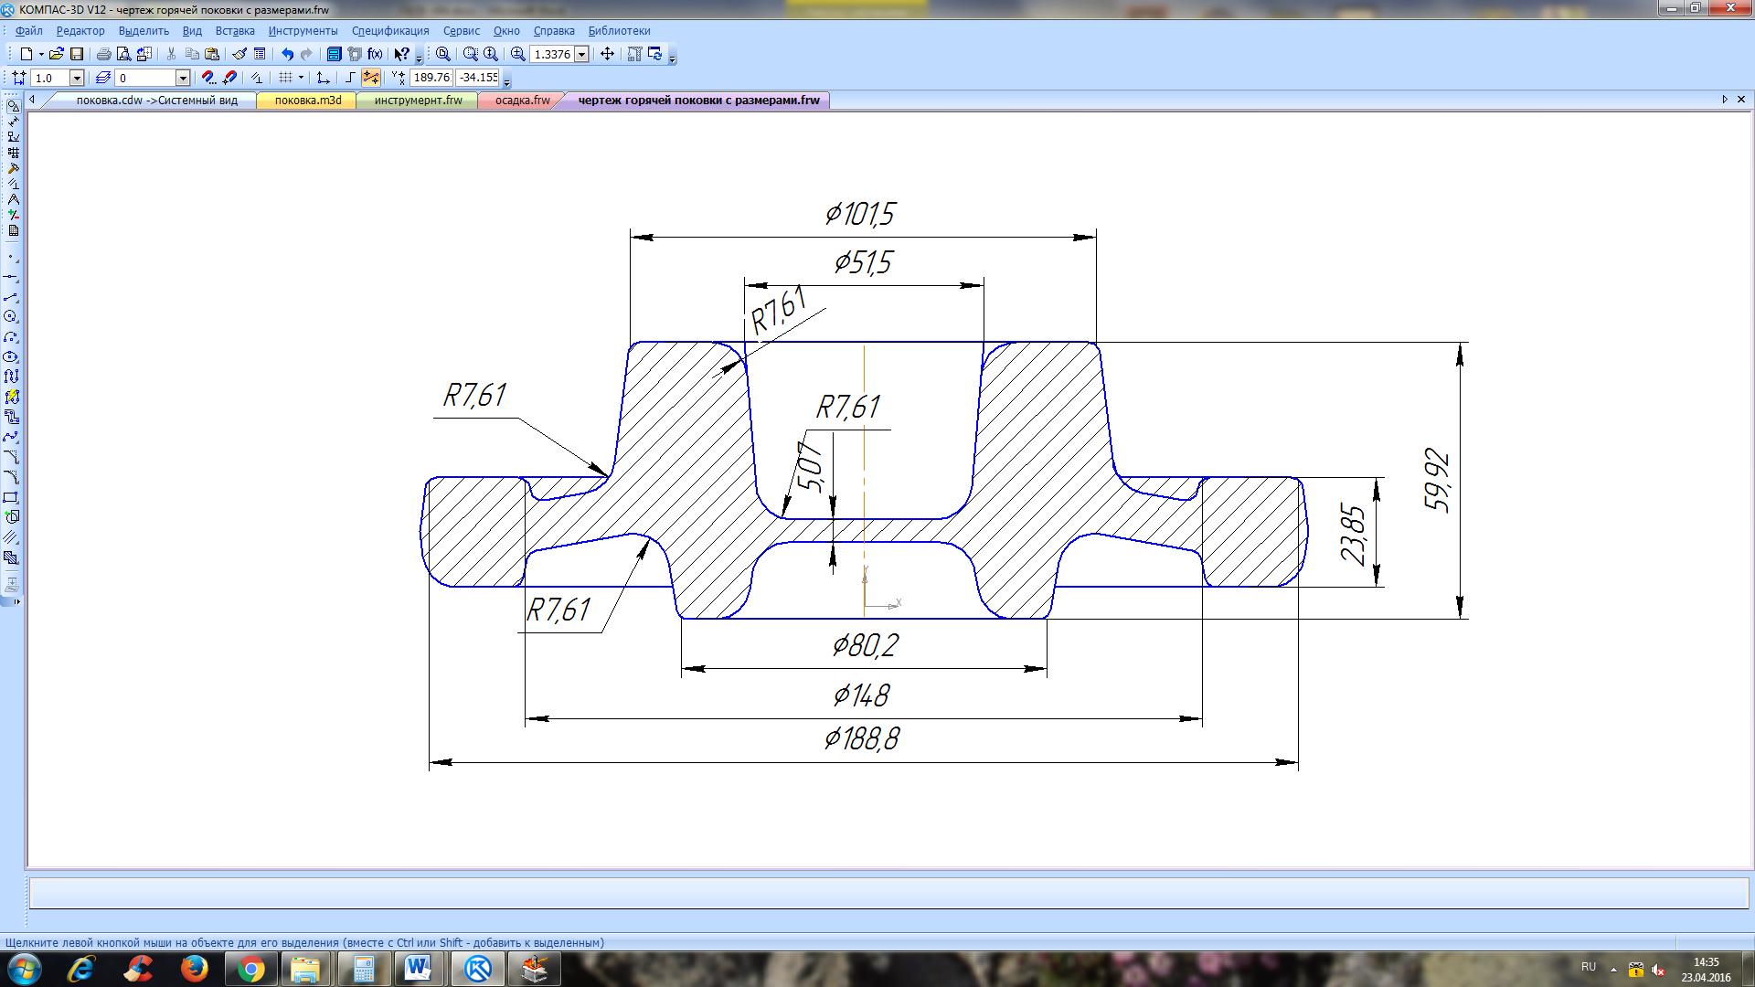

Dimensions of standard gutter may be selected using the following expression:

$$h_{0}=0.013D_{F.P.} ,$$

where $h_{0}$– is the estimated flash thickness at the gutter bridge; $D_{F.P.}$– is the maximum diameter of the forged part . The estimated flash thickness is

$$h_{0}=0.013D_{F.P.}=0.013∙186=2.4\left(mm\right).$$

The thickness is selected nearest to the estimated and equal of 2. The dimensions of the type I gutter are specified in the table below.

|  |  |  |  |  |  |
| --- | --- | --- | --- | --- | --- |
|  |  | R | b | b1 | S*g* |
| mm | mm | mm | mm | mm | cm2 |
| 3 | 5 | 2.0 | 10 | 28 | 2.01 |

**Simulation in the QForm software**

**1. Analysis of the die impression filling.**

The die impression is oriented on the way that largest cavity is on the top and provided in order to make it easier to extract the forged part.

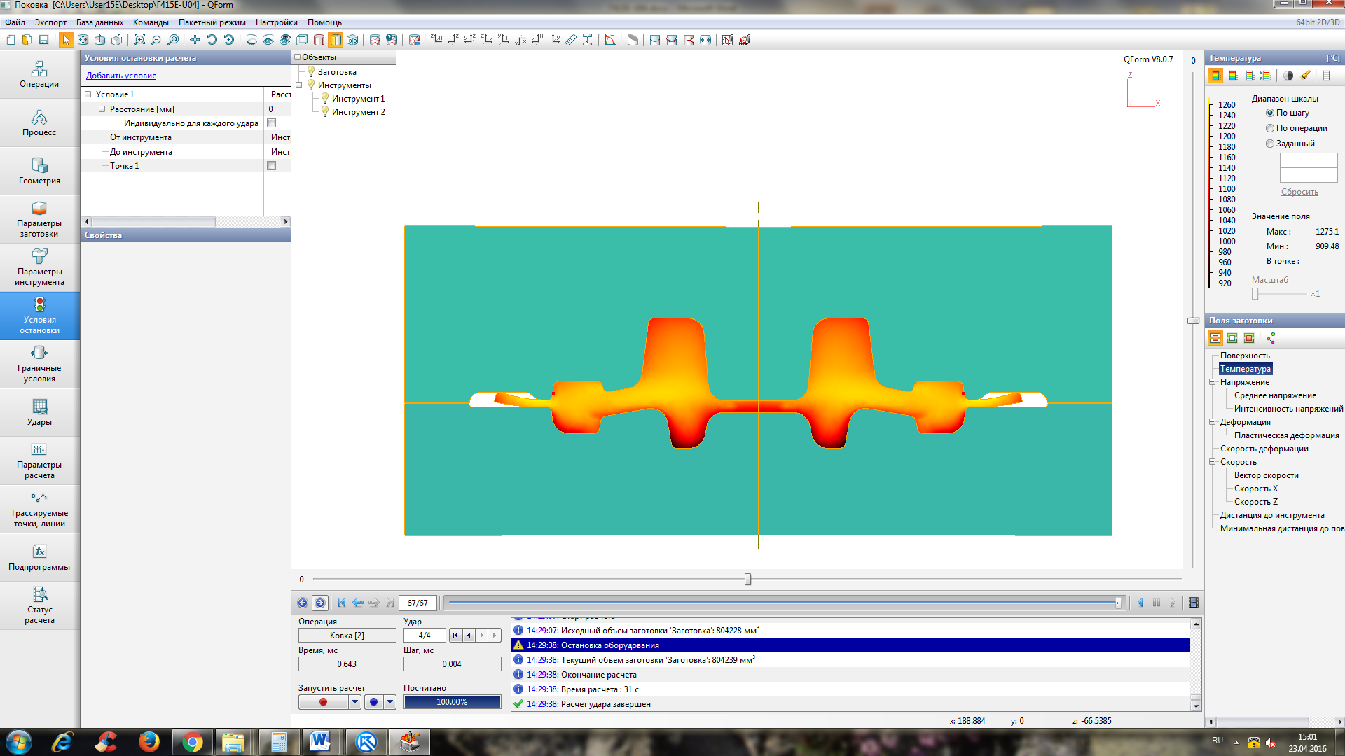

The forged part is formed with no unfilled cavities, a little amount of metal has flown in the gutter, as is seen from the figure above. Therefore, the workpiece volume has calculated Correctly!!!

1. **Analysis of power and force operation parameters of the equipment selected.**

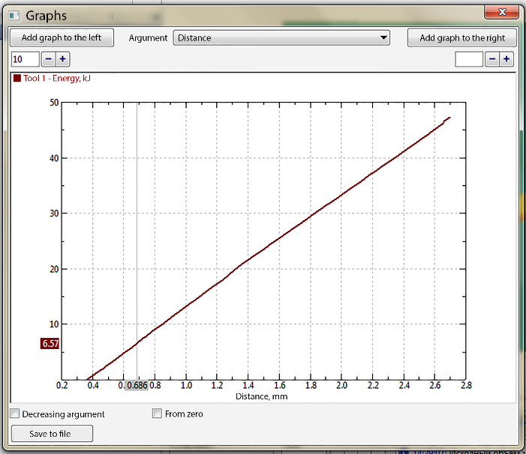

The 2 tons, 50 kJ hammer is selected.

|  |  |
| --- | --- |
| The first stroke | The second stroke |

|  |  |
| --- | --- |
| The third stroke | The fourth stroke (the last) |

It has shown clearly on the figures that deforming force is high.

It follows from several derivative factors:

1. A high complexity of the initial detail (deep cavities, thin swashed rim, massive hub relatively to the whole detail etc.).
2. A small range of equipment (it is impossible to choose the most appropriate one).

**3. Allocation of defects formation places.**

**The metal jam is beginning to form on the rim at the third stroke.**

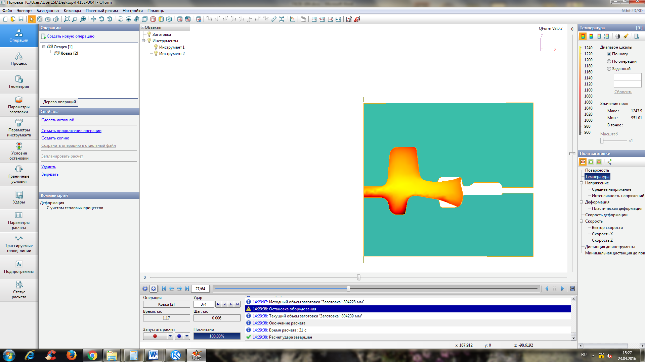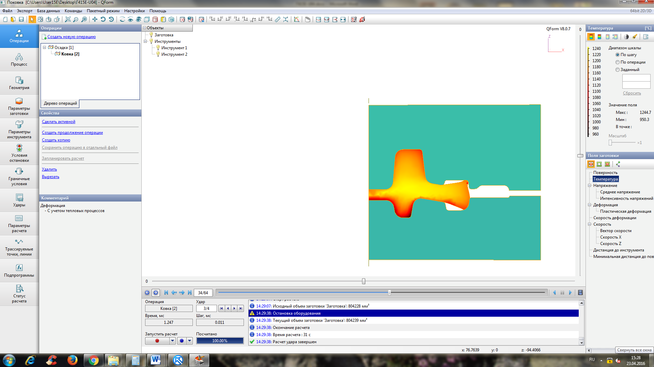

It remains until the end of forging on the surface only and doesn’t stamp inside the forged part.

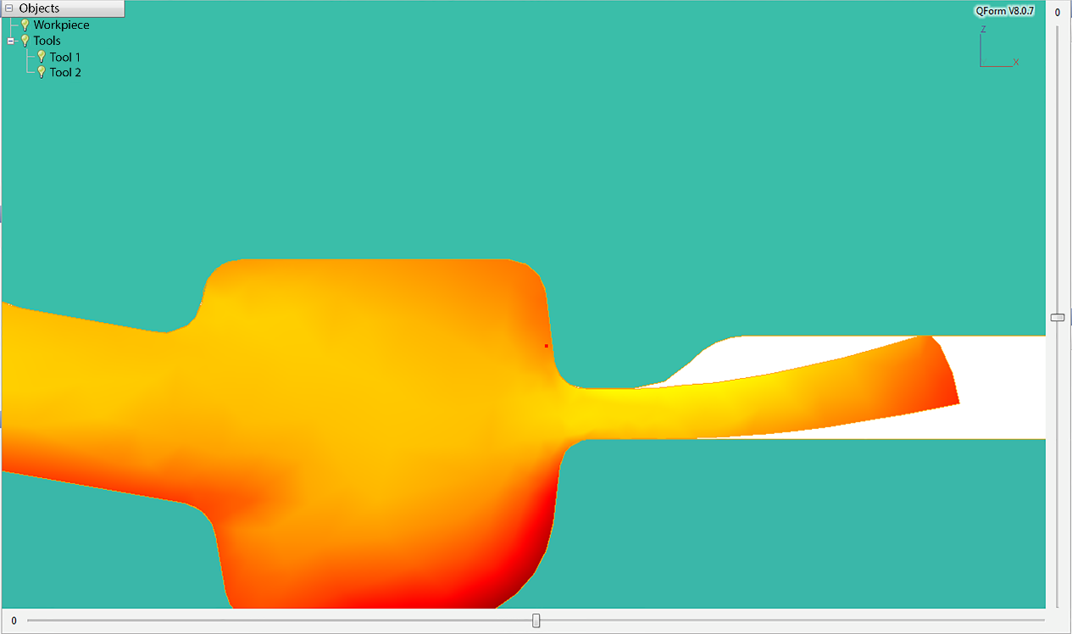

This defect does not damage the detail because it is within the allowance, but may be eliminated in several ways:

1. Change the geometry of the upper part of die impression. Avoid projections and leave a straight section in the rim area. In such case forging metal will not meet obstacles like channel narrowing and be under the influence of compression stresses in this area during the forging process.
2. Ensure by upsetting an overlapping of this pad by the forged part at the beginning of the finish forging, but in this case waste of material or under-forging is possible.
3. Upsetting of the workpiece, not in the flat die, but in the die with a conical part at the top (the most democratic way).

**4. Analysis of temperature and deformation fields**

The forging temperature region for this material is 1200-700 degrees Celsius.

The temperature in the deformation zone during the forging process rises up to 1240 degrees Celsius at the 2 and 3 strokes that is not so good, but not critical because it is possible to change the temperature conditions and provide recrystallization annealing after the forging.

There are dead zones formed in the hub during forging. The forged part is cooling faster there due to lack of deformation and a degree of deformation is not so high there. This is not true concerning the gutter zone where the deformation zone is located during the whole process.

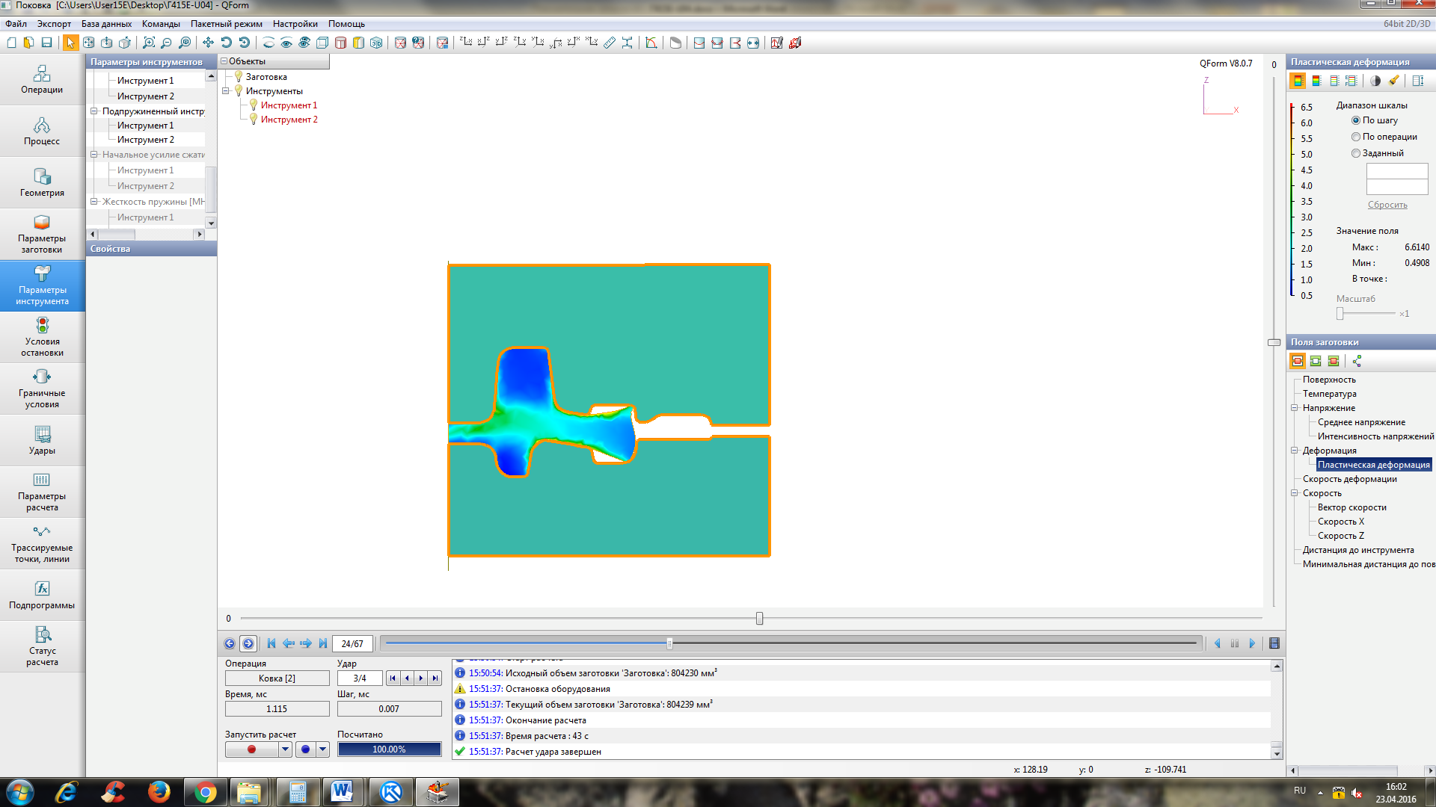

**Stress analysis in the die**

Stresses at the base of the sign are appearing during the forging process even at the 1 stroke.

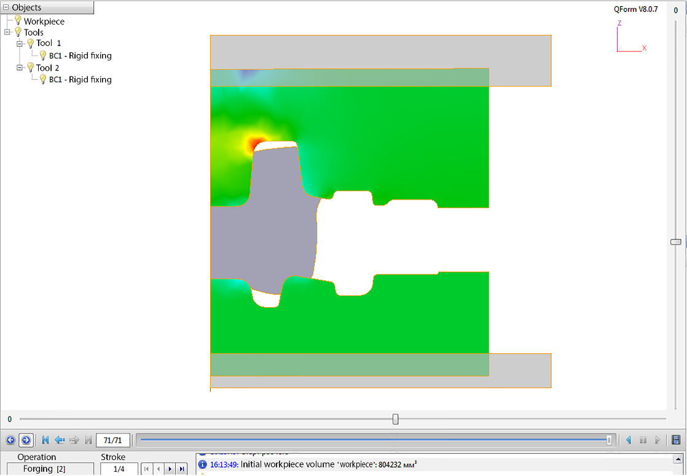

The deformation zone moves to the other side of the base of the hub starting with the 2 stroke.

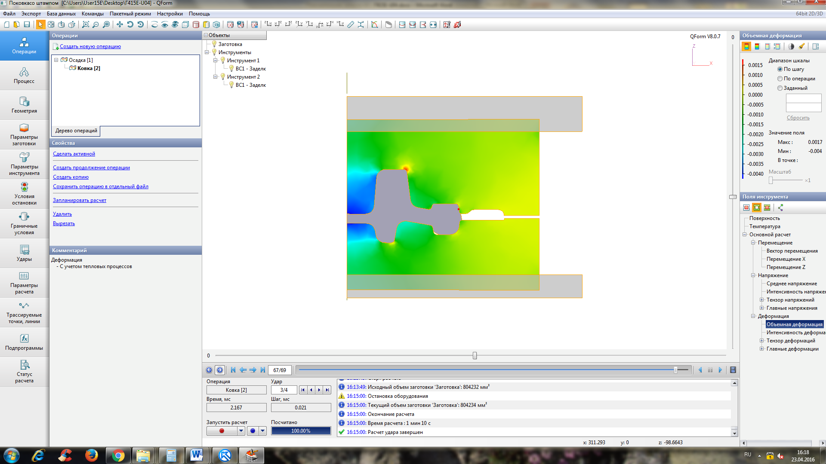

And so it is taken place until the end.

The deformations here are, correspondingly, large too.

There are almost no stresses, as observed on the sign, although the friction is expected during the 1 stroke.

**The die design improvement proposal**.

It is possible to make the spherical radii larger in the place where stresses are appearing to avoid stress concentration.

The whole die is damage resistant!

The technology improvement proposal will pay off!